FoSSIL FUEL PRICES, INTEREST RATES, METAL PRICES, AND ECONOMIC ACTIVITY IN THE UNITED STATES

Continuous Assessment 3:
Final Capstone Project
https://www.youtube.com/watch?v=LlFJomgdjzM

Darren O’ Connell
SBA23255

Email




You Tube link to presentation video: https://www.youtube.com/watch?v=LlFJomgdjzM


Fossil Fuel Prices, Interest Rates, Metal Prices, and Economic Activity in the United States

Abstract

This study explored time series data extracted from the FRED repository using the CRISP-DM methodology. Initial exploratory analysis revealed strong correlations between commodity prices for crude oil, gold, iron ore, and copper with the target variable, US manufacturers’ sales. The target variable was used as an expedient proxy barometer of economic activity in the United States. Feature contribution analysis using Pearson and Spearman correlation coefficients respectively and mutual information regression confirmed that these features were appropriate for subsequent modelling and evaluation. Stationarity tests (viz., ADF and KPSS) confirmed the non-stationary nature of most features in the dataset. Subsequent detrending by differences led to significantly weaker correlations between the independent and target variables. Hence, modelling exclusively employed non-stationary data to capture underlying patterns and trend dynamics not inherent in the detrended data. Four tuned and cross-validated conventional machine learning algorithms and one deep learning neural network were trained on normalised data and evaluated using the optimum test split. The best conventional model, XG Boost outperformed the neural network with a Mean Absolute Percentage Error (MAPE) of 12.47% compared to 83.79% respectively. XG Boost was subsequently trained on normalised data featuring a temporal lag of 1 month and evaluated using the optimum test split. Residual analysis confirmed that the model fitted well to the lagged data. In contrast to the unlagged data, the MAPE score increased to 23.1%. According to SHAP analysis, gold and copper exerted the most influence on the predictive output of XG Boost when exposed to test data lagged by 1 month. Feature ablation analysis confirmed that gold and iron ore exhibit the most significant impact upon model performance for both lagged and unlagged data. These features may be leveraged as potential signals when forecasting changes in economic activity in the United States. Since economic activity is influenced by a myriad of factors not explored in this study, further research is necessary before definitive conclusions can be drawn about the optimal signal mix for economic forecasting. [327]

Keywords:
CRISP-DM, FRED, ADF, KPSS, XG Boost, SHAP, feature ablation, stationarity, detrending, commodity prices, economic activity, economic forecasting, United States.

GitHub link:
https://github.com/Darren-SBA23255-CCT-L8/Strategic_Thinking_HCI_S2

Word Count:
4994 – Excludes titles, sub-titles, figure captions, and references.

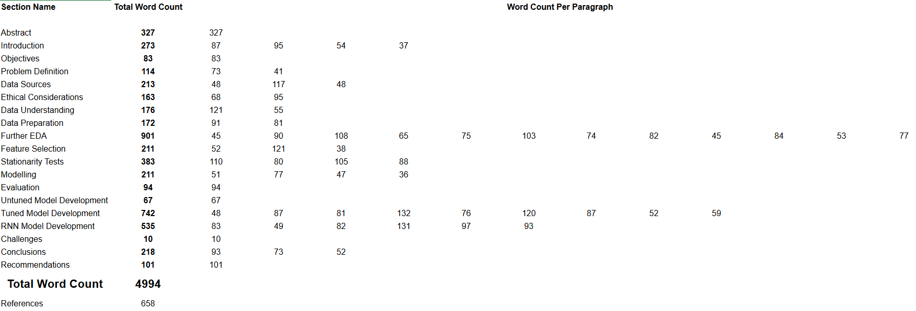

Table of Contents

Project Management Flowchart 9
Introduction 10
Objectives 11
Problem Definition 11
Data Sources 12
Ethical considerations 13
Data Understanding 14
Data Preparation 16
Further Exploratory Data Analysis 18
Feature Selection 33
Stationarity Tests 35
Modelling 58
Evaluation 59
Untuned Model Evaluation 60
Tuned Model Evaluation 66
RNN Model Evaluation 73
Challenges 77
Conclusions 78
Recommendations 79
References 80

Project Management Flowchart

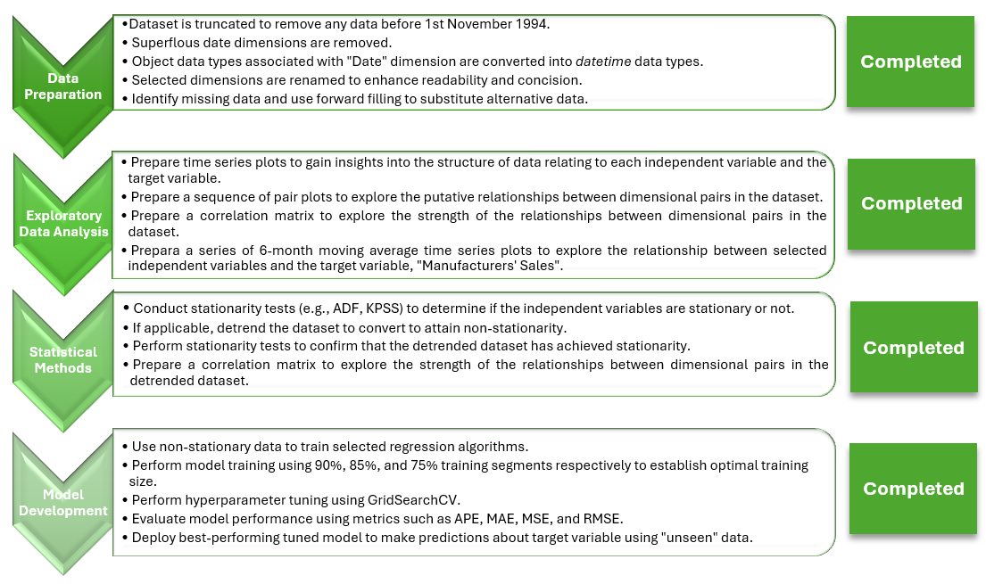

Introduction

Economic forecasting is the science of attempting to anticipate economic activity using a myriad of key economic indicators. Traditionally, economic forecasting entails the application of conventional statistical models in a bid to calculate the economic growth rate. Metrics such as inflation, interest rates, industrial production, consumer sentiment, worker productivity, retail sales, and unemployment rates are analysed to determine expected economic activity (Liberto, 2024). However, economic forecasting is not necessarily an exact science, since human bias and subjectivity when interpreting economic metrics can lead to inaccurate predictive models. [87]

Crude oil and natural gas are two of the most important energy commodities in the world (US Federal Government, 2020). Previous research (Baumeister and Kilian, 2017; Baumeister, Kilian, and Zhou, 2018) shows that increases in the real price of crude oil inexorably leads to higher gasoline and energy prices accompanied by a discernible reduction in household disposable income. At the same time, higher gasoline prices raise the operating cost of vehicles, therefore increasing transportation costs throughout the economy. Suffice it to say that fluctuations in fossil fuel prices exert an appreciable impact upon economic activity. [95]

Changes in interest rates by the US Federal Reserve can also impact economic activity (Maverick, 2023). The US Federal Reserve typically adjusts interest rates in order to combat inflation or promote economic activity. When interest rates are low, borrowing becomes more affordable for individuals and businesses, while higher interest rates make borrowing more expensive. [54]

Since gold and other precious metals (Fernando, 2024), copper (Chen, 2021), and iron ore (Murry, 2022) are deeply intertwined with the global economy, shifts in their prices may signal potential upward or downward trends in economic activity. [37]

Objectives

The objective of this study was to elucidate any causal linkages between global fossil fuel prices, liquefied natural gas (LNG), metals, consumer price index (CPI), and interest rates with economic activity in the United States using the CRISP-DM methodology (Martínez-Plumed et al., 2021). Manufacturers’ sales were used as a proxy barometer of economic activity. Moreover, machine learning models and neural networks were developed in a bid to predict manufacturers’ sales - and by extension, economic activity - for a specific period in time. [83]

Problem Definition

While machine learning has been used in the recent past to forecast fluctuations in crude oil prices (Qin et al., 2023, Abdullah and Zeng, 2010) and LNG prices (Yang et al., 2023, Kim et al., 2022), no substantive research has been carried out to explore if machine learning and neural networks can be used to predict economic activity on the basis of variations in fossil fuel prices, metals prices, interest rates, and CPI. [73]

For this reason, this study endeavoured to apply machine learning methodologies to predict US manufacturers’ sales for a given month. Moreover, attempts were made to identify one or more specific features that may be leveraged as potential signals for economic forecasting. [41]

Data Sources

The data used in this study is primarily extracted from FRED, an online database comprising hundreds of thousands of economic time series aggregated from national, international, public, and private sources. FRED is maintained by the Research Department at the Federal Reserve Bank of St. Louis, Missouri, United States. [48]

- Crude Oil Prices: Brent – Europe
https://fred.stlouisfed.org/series/DCOILBRENTEU
- Crude Oil Prices: West Texas Intermediate (WTI) to Cushing, Oklahoma
https://fred.stlouisfed.org/series/DCOILWTICO
- Global Price of LNG, Asia
https://fred.stlouisfed.org/series/PNGASJPUSDM
- Commercial Bank Interest Rate on Credit Card Plans
https://fred.stlouisfed.org/series/TERMCBCCALLNS#0
- Flexible Price Consumer Price Index (CPI) - excluding food and energy
https://fred.stlouisfed.org/series/FLEXCPIM679SFRBATL
- Export Price Index (End Use): Nonmonetary Gold
https://fred.stlouisfed.org/series/IQ12260
- Global price of Iron Ore
https://fred.stlouisfed.org/series/PIORECRUSDM
- Global price of Copper
https://fred.stlouisfed.org/series/PCOPPUSDM
- US manufacturers' sales
https://fred.stlouisfed.org/series/MNFCTRSMNSA

The frequency of the time series data is monthly for ease of analysis. Non-seasonally adjusted (NSA) data was used to ensure fair comparisons between disparate datasets. Seasonally adjusted data was not used to avoid introducing biases into the datasets (Doppelt, 2023). [117]

The relevant time series data were consolidated in a Microsoft Excel spreadsheet to create the final dataset, “Consolidated FRED Source Dataset.csv”. This dataset was imported into a Jupyter notebook for exploratory data analysis (EDA) and data preparation. A preview of the consolidated dataset is shown in Figure 1. [48]

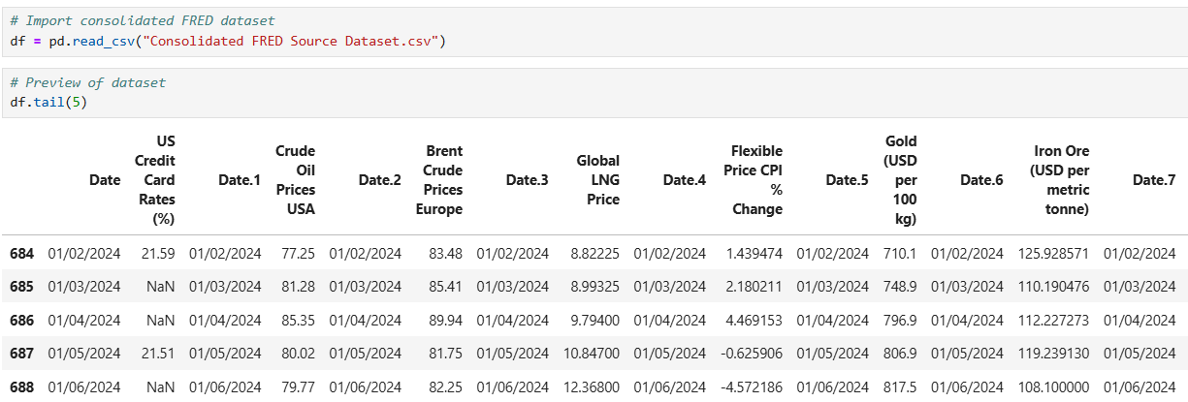
Figure 1. A preview of the imported dataset, "Consolidated FRED Source Dataset.csv".

Ethical Considerations

According to a paper presented at the 2018 Conference on Fairness, Accountability, and Transparency in Machine Learning, R. Binns contended that there are several key ethical considerations that must be addressed when analysing datasets relating to macroeconomic activity. These ethical considerations are presented below:

- Data Privacy and Confidentiality
- Informed Consent
- Bias and Fairness
- Potential for Misuse
- Impact on Vulnerable Populations
- Transparency and Accountability
- Long-term Data Stewardship
- Regulatory Compliance [68]

Most of the ethical considerations alluded to above are not relevant to this study. Since the source datasets extracted from the FRED repository are public domain and aggregated, there is no inherent risk of compromising data privacy and confidentiality. Seasonally adjusted data is eschewed to minimize the risk of introducing biases into the source datasets (Mamedli, 2021). Instead, unadjusted time series data is used for more accurate comparative analysis between different datasets for a specific time period as well as optimizing the predictive capabilities of machine learning models and neutral networks trained on the data. [95]

Data Understanding

The dataset comprises 20 features distributed amongst float and object data types. There are 689 observations in the unpreprocessed dataset.

The scope of the time series applicable to each feature is shown in the following statement:

Flexible Price CPI (% change):
01-02-1967 to 01-06-2024
US crude oil prices per barrel (USD $):
01-01-1986 to 01-06-2024
Brent crude oil prices (Europe) per barrel (USD $):
01-05-1987 to 01-06-2024
Global LNG price per million metric British thermal unit (BTU):
01-01-1992 to 01-06-2024
US manufacturers’ sales (millions, USD $):
01-01-1992 to 01-06-2024
US credit card rates (%):
01-11-1994 to 01-06-2024
Gold (USD per 100kg):
01-11-1994 to 01-06-2024
Copper (USD per metric tonne):
01-11-1994 to 01-06-2024
Iron Ore (USD per metric tonne):
01-11-1994 to 01-06-2024 [121]

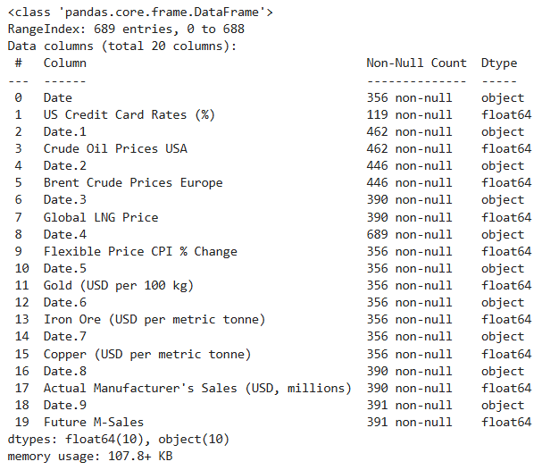
Figure 2. List of data types associated with each dimension in the dataset.

Since the time series associated with each dimension does not begin at the same date (e.g., 01-02-1967), there is a significant quantity of missing values. In order to minimise the adverse influence of missing values on data completeness and quality, the scope of the dataset was truncated from 1st November 1994 to 1st June 2024. [55]

Data Preparation

During the data preparation stage, the following sequential steps were taken to improve data consistency and quality:

- The dataset was truncated to remove any data prior to 1st November 1994.
- Superfluous date dimensions were removed from the dataset.
- Object data types associated with “Date” were transformed into datetime data types.
- Selected features were renamed to render the corresponding labels concise and more readable. For example, “Actual Manufacturer's Sales (USD, millions)” was converted into “Manu Sales (USD, millions)”.

The Python code pertaining to the preceding preprocessing steps is shown in Figure 3. [91]

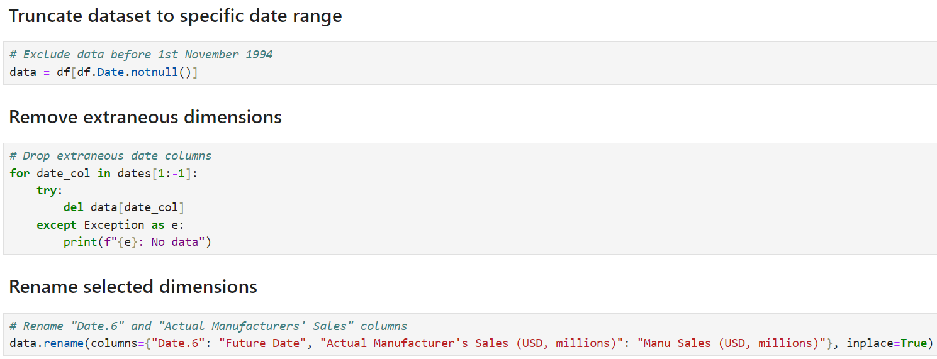
Figure 3. The Python code shown in this figure is used to restrict the date range of the dataset, remove extraneous features, and rename selected features.

The next step entailed the application of the “find_missing_values” function to the truncated dataset. There were 237 missing values within the dataset relating to the dimension, “US credit card rates (%)”. No other missing data was reported. The “pad” (or forward fill) method was used to propagate the last valid observation forward to the next valid observation. Accordingly, missing values for “US credit card rates (%)” were filled. The Python code relating to the preceding steps are shown in Figure 4. [81]

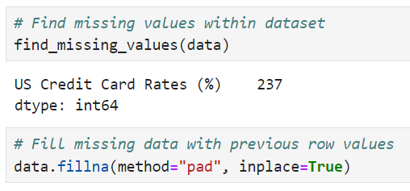
Figure 4. The “find_missing_values” function was used to find features with missing values. The only dimension with missing data was US credit card rates (%). The “fillna” method was used to replace missing data by “forward filling”.

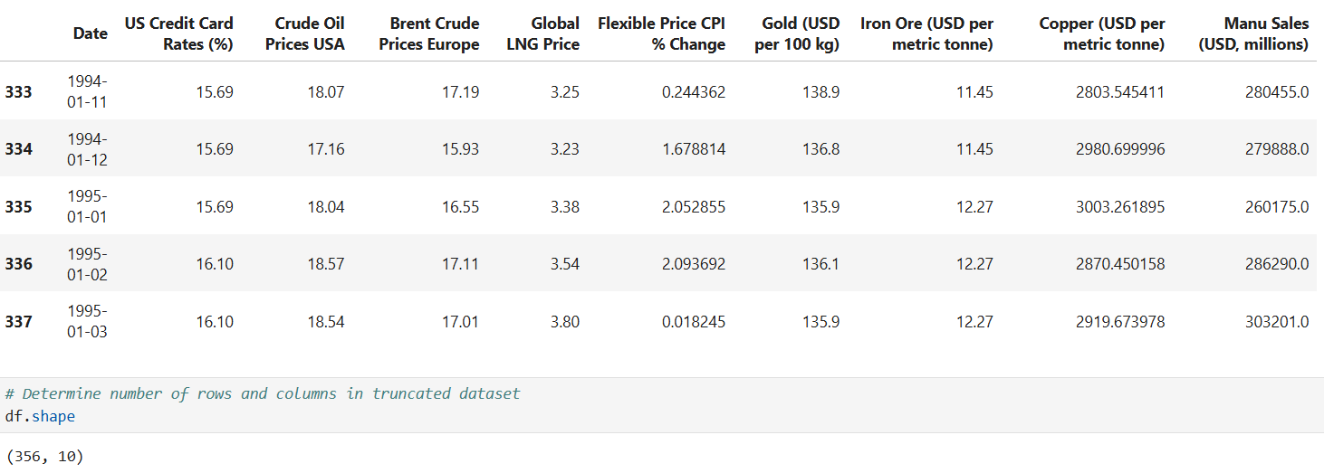
Figure 5. A preview of the truncated dataset. The data in the truncated dataset spans the range from 1st November 1994 to 1st June 2024 (inclusive).

Further exploratory data analysis

Using the truncated dataset shown in Figure 5, further exploratory analysis was performed on the remaining 10 features and 356 observations. The objective of this analysis was to use graphical representations of the data to uncover underlying patterns and trends, spot anomalies, and posit hypotheses. [45]

The truncated dataset was normalised due to the varying scales of measurement across input features and the target variable. The normalisation process scaled the data to a range between 0 and 1, standardising values while preserving any latent relationships within the data. The normalised data is presented in Figure 6. In consequence, normalisation enhances data comparability regardless of their original magnitude or measurement units (Kumar, 2025). Moreover, normalisation improves the performance of many data analytical techniques and machine learning models, thereby ensuring robust and meaningful analysis (Cabello-Solorzano et al., 2023). [90]

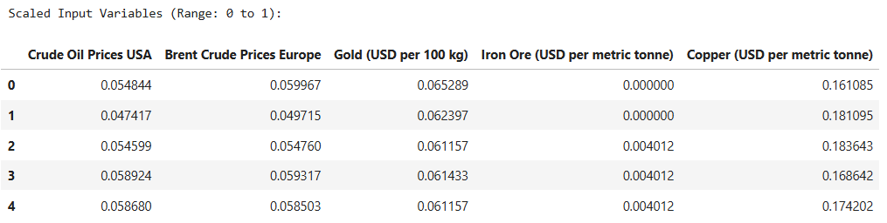
Figure 6. Normalised dataset where features are converted from their original scales of measurement to a range between 0 and 1, thereby preserving any underlying relationships in the data.

Figure 7 shows an overlay plot created using the normalised data. Multiple line plots relating to the features are superimposed within the same coordinate space. These line plots were used to identify any relationships, differences, or similarities between the input features and the target variable. At first sight, no apparent similarities exist between the respective input features and the target variable. However, upon closer examination, the line plots representing "Crude Oil Prices USA" and "Brent Crude Prices Europe" seem to exhibit trends that closely align with variations observed in the target variable. Accordingly, it may be inferred that these features demonstrate a potential correlation with US manufacturers' sales. [108]

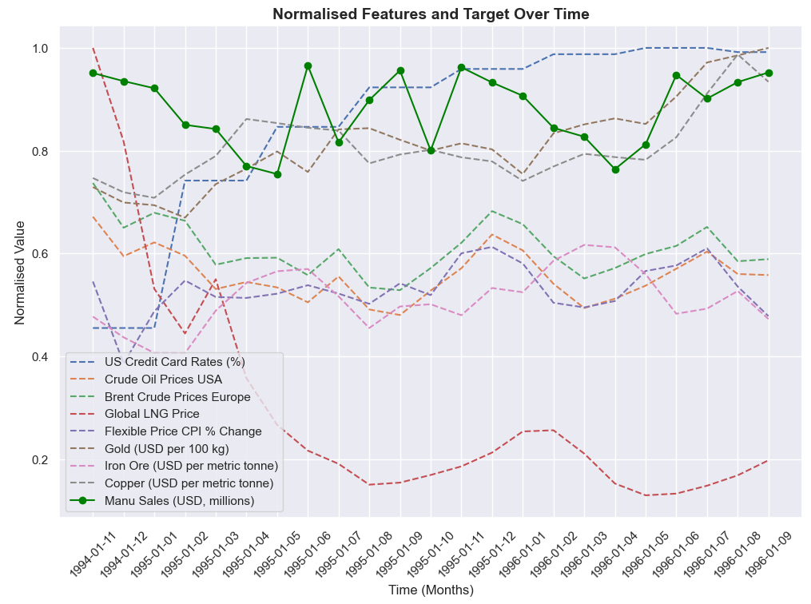
Figure 7. Overlay plot showing trends relating to input features and target variable, US manufacturers' sales. This plot shows potential correlations between input features and target variable by visually comparing their fluctuations and temporal alignment across the normalised dataset.

To further explore the relationships between the normalised features, pair plots are presented in Figure 8. These plots were used to help identify patterns, trends, correlations, and potential outliers in the dataset. The last row of pair plots shows the relationship between the input features and the target variable. It is manifestly evident there is a discernible relationship between most features and US manufacturers’ sales. [65]

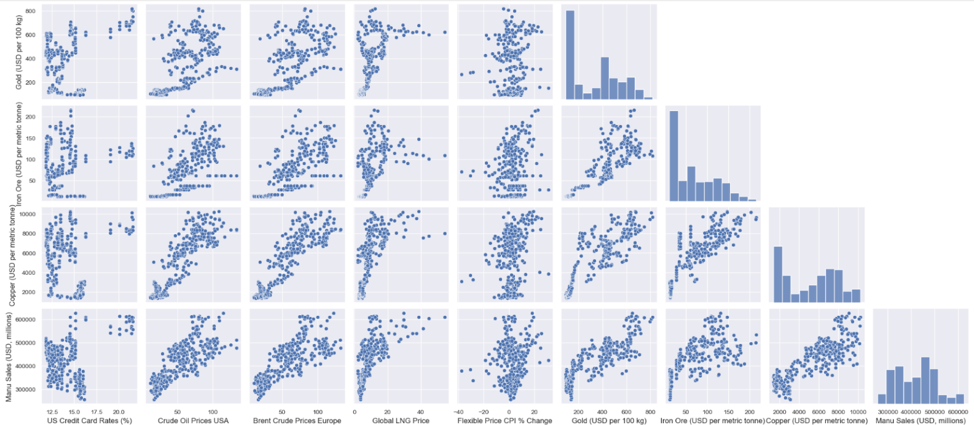
Figure 8. Pair plots showing the relationship between input features and the target variable, US manufacturers’ sales.

Figure 9 demonstrates a magnified version of these pair plots. With the exception of “US Credit Card Rates (%)” and “Flexible Price CPI % Change”, there is a reasonably strong positive correlation between the independent features and the target variable. By and large, increases in crude oil prices, LNG, copper, gold, and iron ore respectively are accompanied by increases in economic output. Further exploration of this phenomenon is necessary before any definitive conclusions are drawn. [75]

In this connection, a series of 6-month “rolling average” line plots are shown in Figure 11 to Figure 16. These line plots exclude “US Credit Card Rates (%)” and “Flexible Price CPI % Change” since these features are not strongly correlated to variations in the target variable. Moreover, variations in the prices of gold and iron ore do not appear to be closely aligned with changes in economic output. In contrast, variations in the commodity prices of the remaining features generally follow changes in US manufacturers’ sales. This observation is corroborated by visual analysis of the corresponding plots, which highlight these consistent trends. [103]

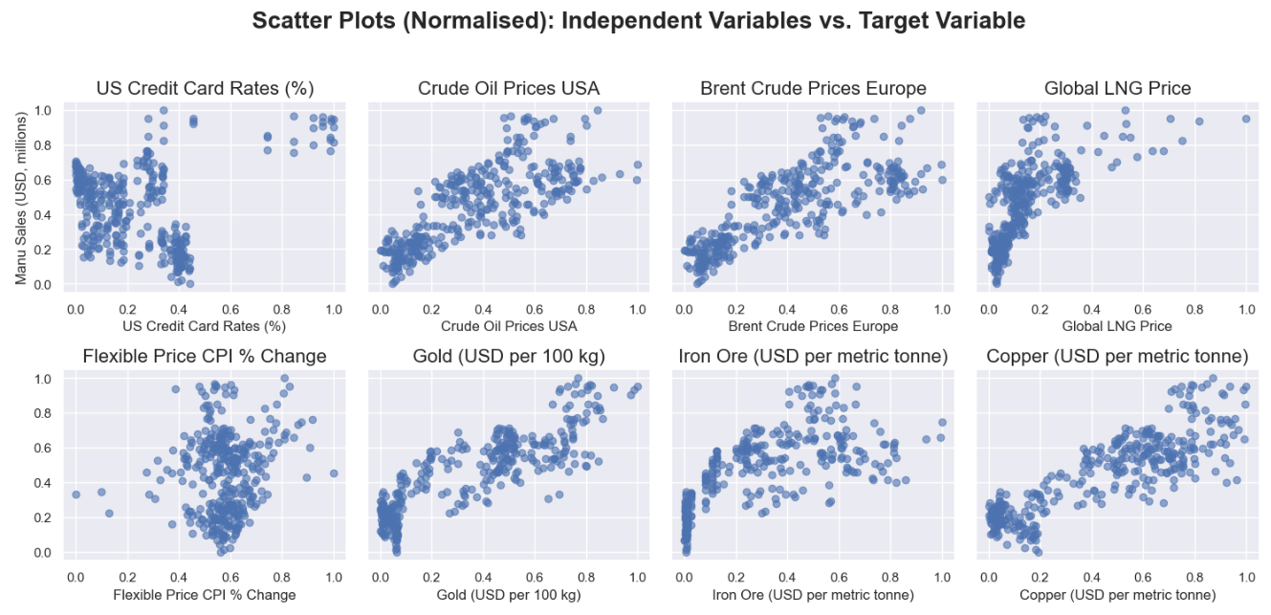
Figure 9. Scatter plot matrix showing the relationships between independent features and the target variable, US manufacturers’ sales. The scatter plots were generated using normalised data to enhance comparability and identify potential correlations.

To gain a further understanding of the strength and direction of the relationships between the independent features and target variable, a correlation matrix and heatmap is shown in Figure 10. The strongest positive correlation with US manufacturers’ sales is exhibited by gold (0.86), copper (0.85), US crude oil (0.77), Brent crude oil (0.79), and iron ore (0.71) respectively. To streamline the analysis, independent features with correlation scores below 0.70 were excluded from further consideration. [74]
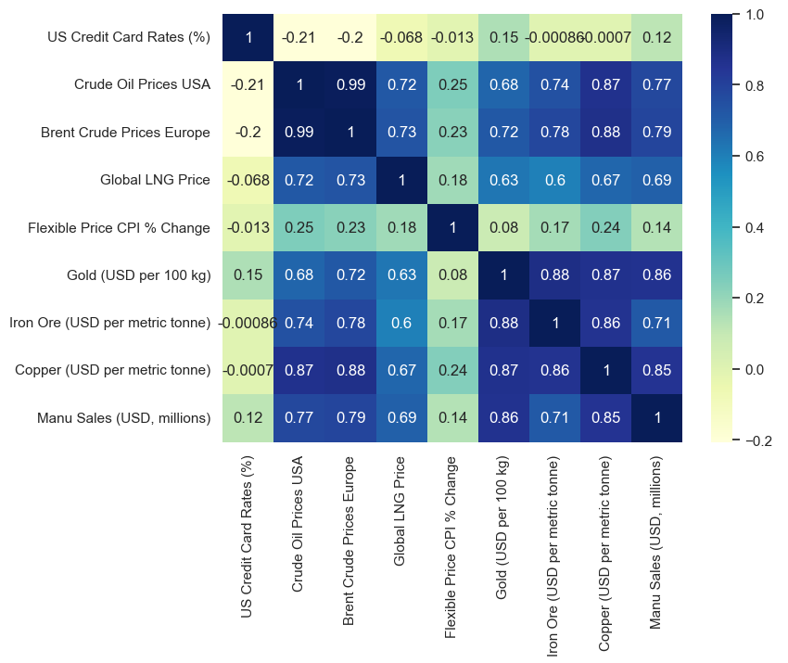
Figure 10. A correlation matrix and heatmap. The strength and direction of the linear relationships between input features and target variable, US manufacturers’ sales are visualised.
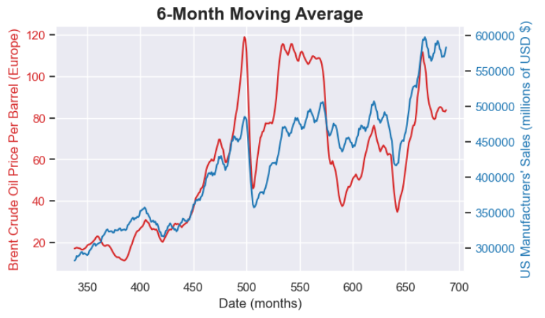
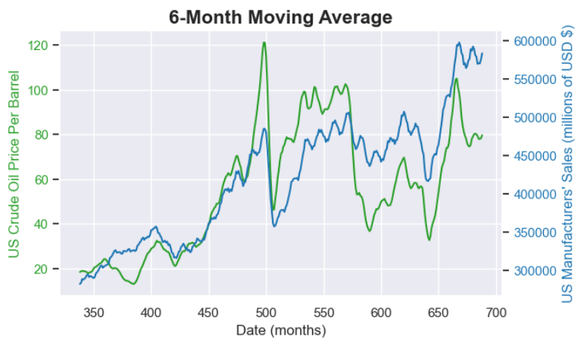
Figure 12. Time series plots for Brent crude oil prices (USD $ per barrel) and US manufacturers' sales (USD $, millions) using a 6-month rolling average.
Figure 11. Time series plots for US crude oil prices (USD $ per barrel) and US manufacturers' sales (USD $, millions) using a 6-month rolling average.
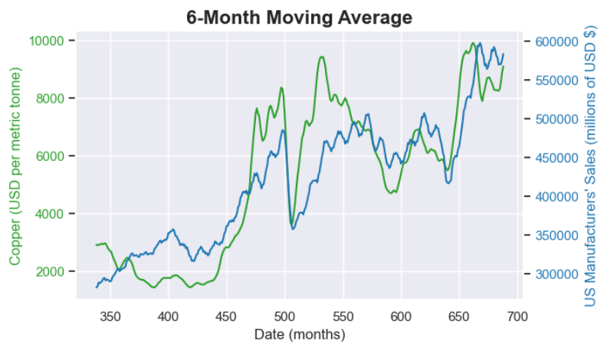
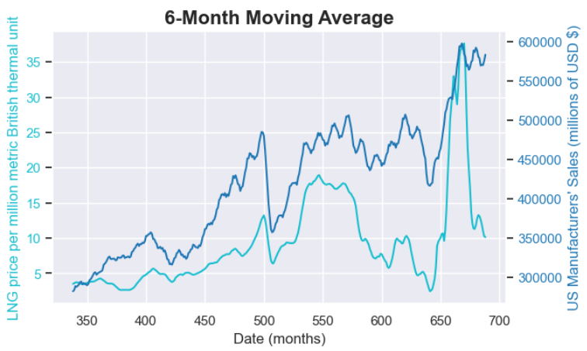
Figure 14. Time series plots for copper (USD $ per metric tonne) and US manufacturers' sales (USD $, millions) using a 6-month rolling average.
Figure 13. Time series plots for LNG prices (USD $ per million metric British thermal unit) and US manufacturers' sales (USD $, millions) using a 6-month rolling average.
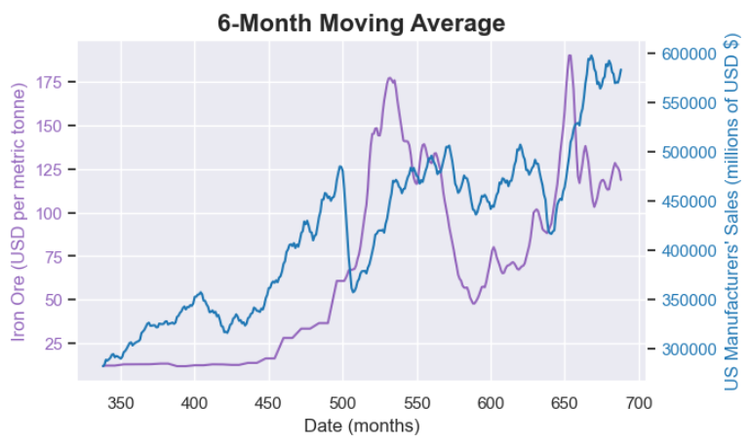
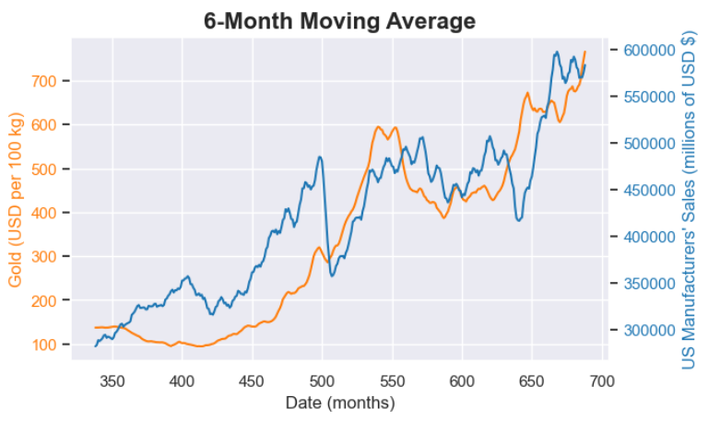
Figure 16. Time series plots for iron ore (USD $ per metric tonne) and US manufacturers' sales (USD $, millions) using a 6-month rolling average.
Figure 15. Time series plots for gold (USD $ per 100kg) and US manufacturers' sales (USD $, millions) using a 6-month rolling average.
Since the secondary objective of this study was to identify commodity pairs that may serve as efficacious indicators for predicting future economic activity in the United States, a series of scatter plots using lagged input features were generated. These plots are shown in Figure 17. Specifically, the normalised input features are lagged by 1 month relative to the target variable, US manufacturers’ sales. This approach facilitates an exploration of how past changes in commodity prices align with future fluctuations in economic activity. [82]

Visual analysis of these plots suggest that commodity prices for crude oil, LNG, gold, copper, and iron ore are possible candidates for forecasting future changes in US manufacturers’ sales and, by extension, economic output. Before any definitive conclusions can be drawn, further analysis is required. [45]
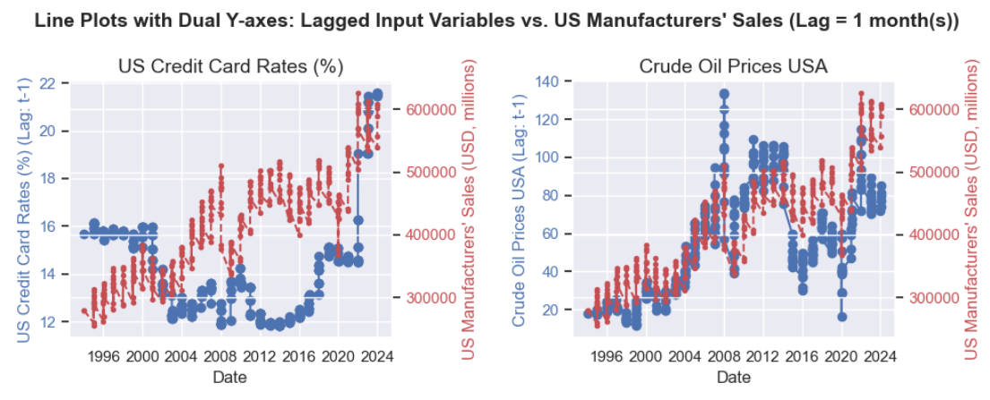
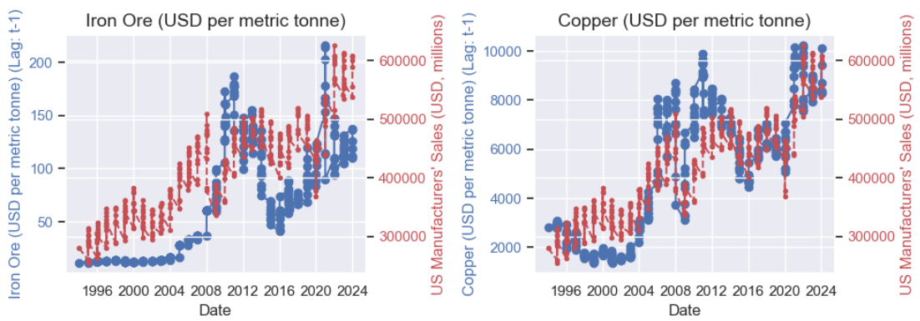
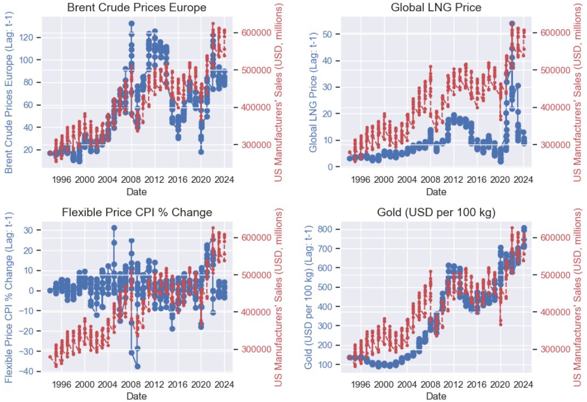
Figure 17. A series of scatter plots showing the relationships between normalised input features lagged by 1 month and the target variable, US manufacturers' sales.

To this end, a correlation matrix and associated heatmap was created to demonstrate the strength and direction of the relationships between the lagged input features and the target variable, “Manu Sales (USD, millions)”. This correlation matrix is shown in Figure 18. Visual analysis of this figure suggests that the lagged prices of copper and gold demonstrate strong positive correlations, with scores of 0.86 and 0.86, respectively. These observations suggest that these commodities may serve as potential signals to forecast future changes in economic output. [84]

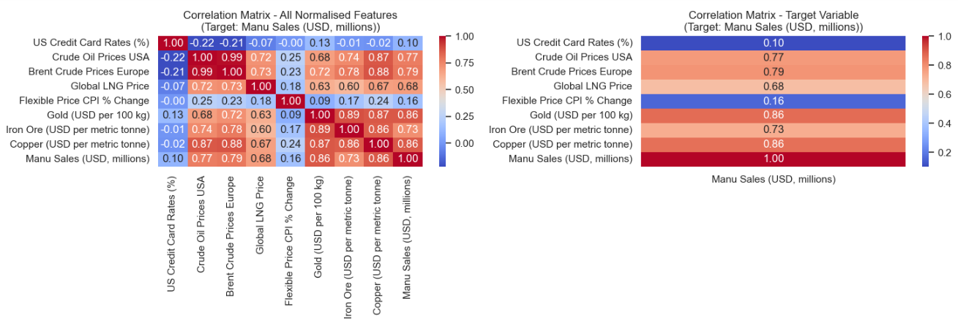
Figure 18. A correlation matrix and associated heatmap showing the strength and direction of the relationships between normalised input features lagged by 1 month and the target variable, US manufacturers' sales.

In contrast, the correlation scores for US credit card rates, % change in CPI, and LNG are 0.10, 0.68, and 0.16, respectively. Since these lagged features do not contribute any meaningful insights to fluctuations in the target variable, these features were excluded from subsequent analysis and modelling (Blessie and Karthikeyan, 2012; Luna, 2021). [53]

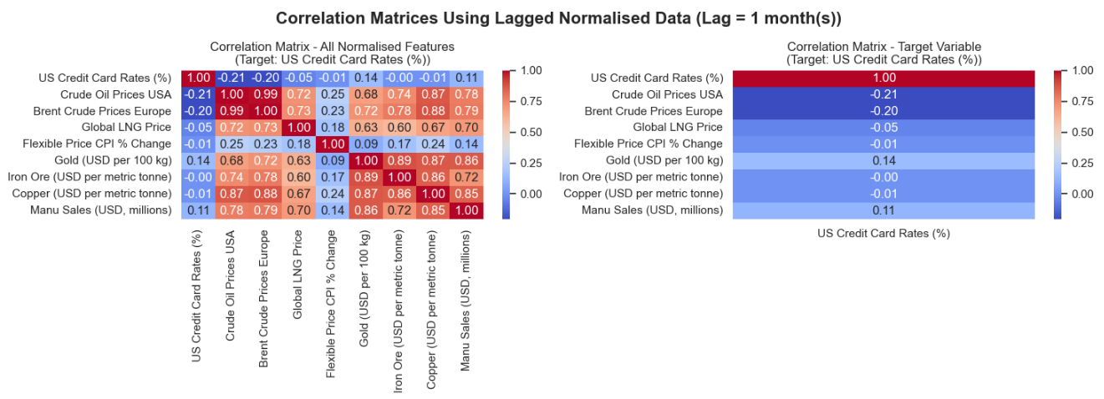
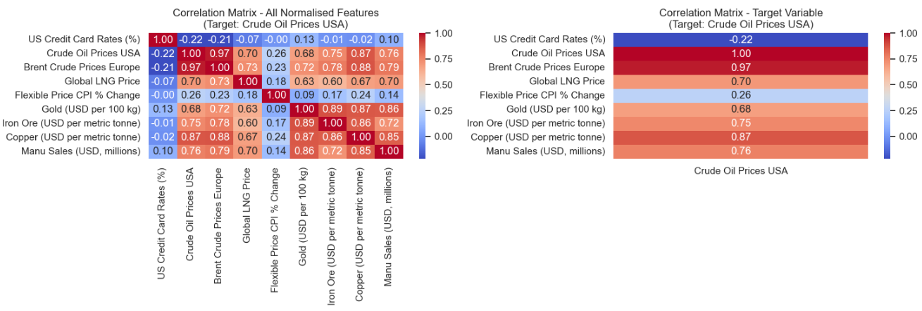
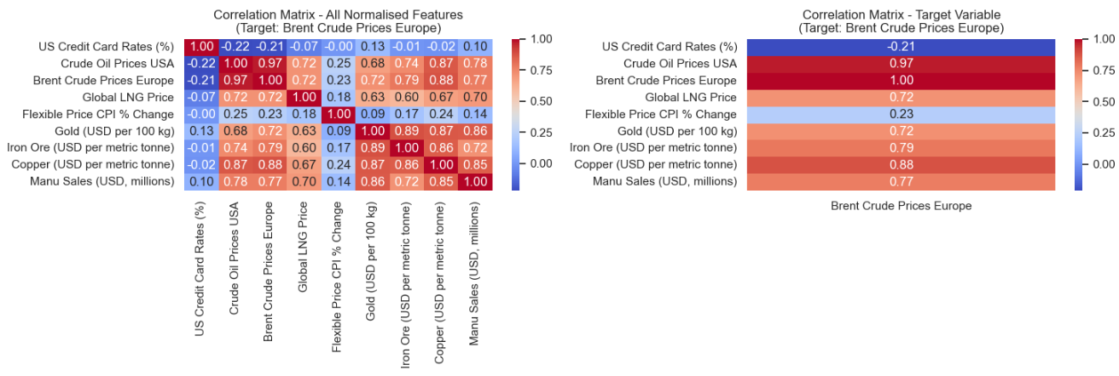

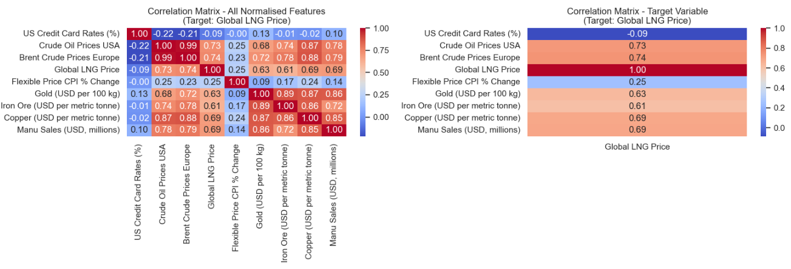
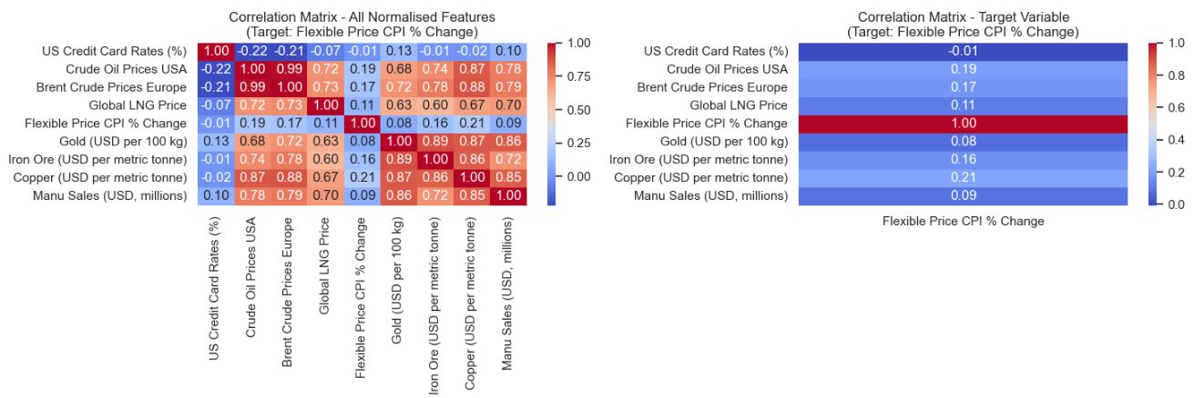
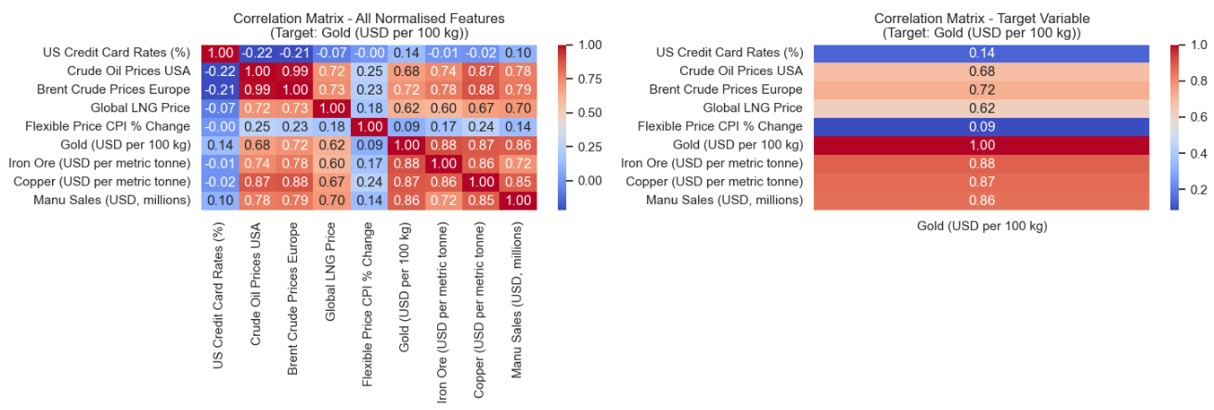

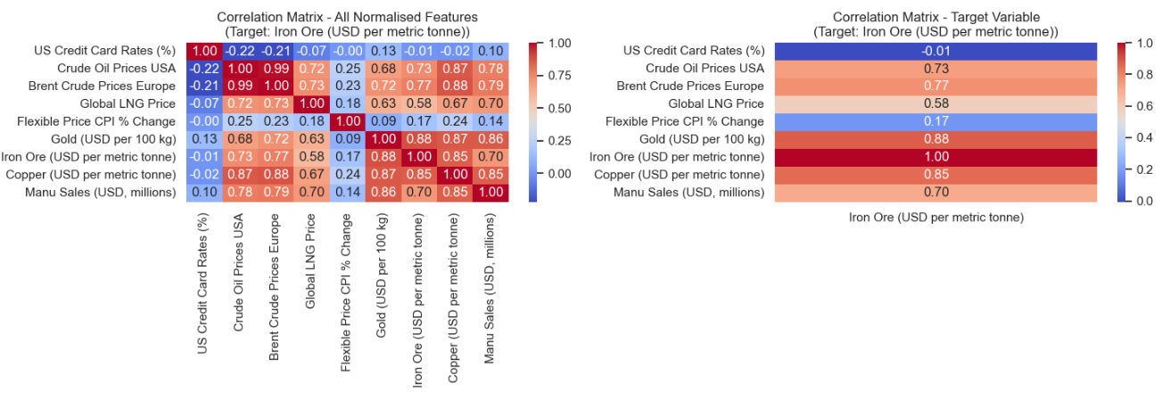
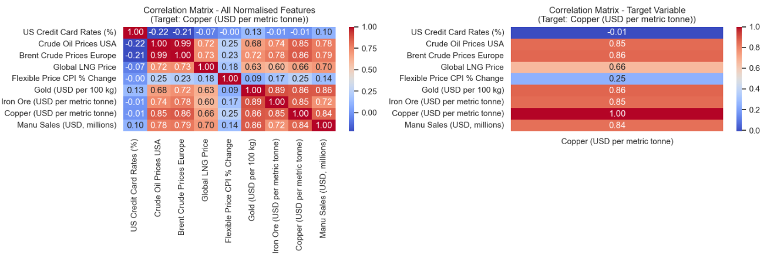

Figure 19. Correlation matrices and associated heatmaps showing the strength and direction of the relationships between normalised input features lagged by 1 month and the selected target variable.

On foot of a visual analysis of the correlation matrix presented in Figure 18, the input features identified for subsequent modelling are:

- Brent Crude Oil Prices (Europe)
- Crude Oil Prices (USA)
- Copper
- Gold
- Iron Ore

These lagged features were provisionally selected due to their strong positive correlations with the target variable. By focusing on these features, it was anticipated that the trained models would exhibit enhanced accuracy and performance, thereby resulting in more reliable and robust predictions. [77]

Feature Selection

It is generally recommended to combine visual analysis of correlation matrices with systematic feature selection to maximise the development of robust, efficient, and interpretable models (Atmakuru et al., 2024). For this reason, Principal Component Analysis (PCA) was used to ascertain the optimal number of features for model development (Song et al., 2010). [52]

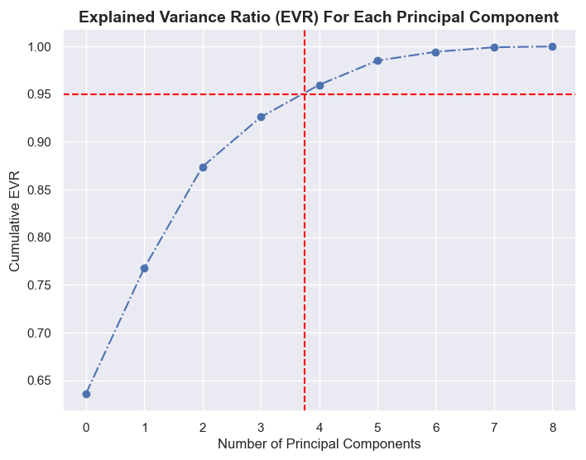
Figure 20. Principal Component Analysis (PCA) was used to determine the optimal number of principal components to achieve 95% variability in the normalised dataset. The plot shows that no more than 4 features should be used during model development.

Figure 20 plots Cumulative Explained Variance Ratio (EVR) against Principal Components. The results indicated that achieving 95% variance requires no more than 4 features for model training and evaluation. This limitation may be attributable to the multicollinearity that exists between US crude oil prices and Brent crude oil prices. According to Figure 19, the correlation score for these features is 0.97. Consequently, it is advisable to drop the feature with the lowest correlation score relative to the target variable (i.e., “Crude Oil Prices USA”, 0.77) and retain “Brent Crude Prices Europe” (0.79). Since the dataset is characterised by low dimensionality and taking into consideration the findings in Figure 21, it was decided to retain both crude oil prices for subsequent modelling. [121]

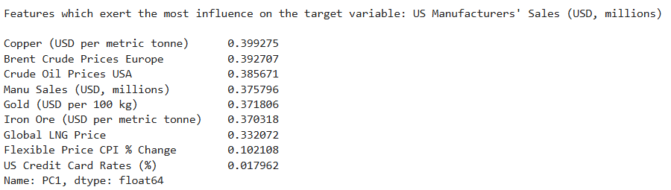
Figure 21. Principal Component Analysis (PCA) confirms which features exert the most influence on the target variable, US manufacturers' sales in descending order.

Similar findings were reported when the Pearson and Spearman correlation scores respectively and mutual information scores relating to the unlagged input features were calculated. The plots relating to these coefficients are presented in Figure 22 to Figure 24. [38]

Stationarity Tests

Whilst it has been provisionally established that specific features exert an influence on the target variable, further proof is necessary that these correlations hold true. In this regard, stationarity tests were carried out. Stationarity tests (i.e., ADF and KPSS) determine if the statistical properties of a time series (e.g., mean, variance, and covariance) remain constant over time (Perktold et al., 2023). Indeed, ensuring stationarity is sometimes a crucial step in preparing time series data for accurate trend identification and modelling, thereby improving the reliability of model predictions. Hence, ADF and KPSS tests are an important pillar of both exploratory data analysis and data preparation (Bawekar et al., 2022; Chatfield, 2000). [110]

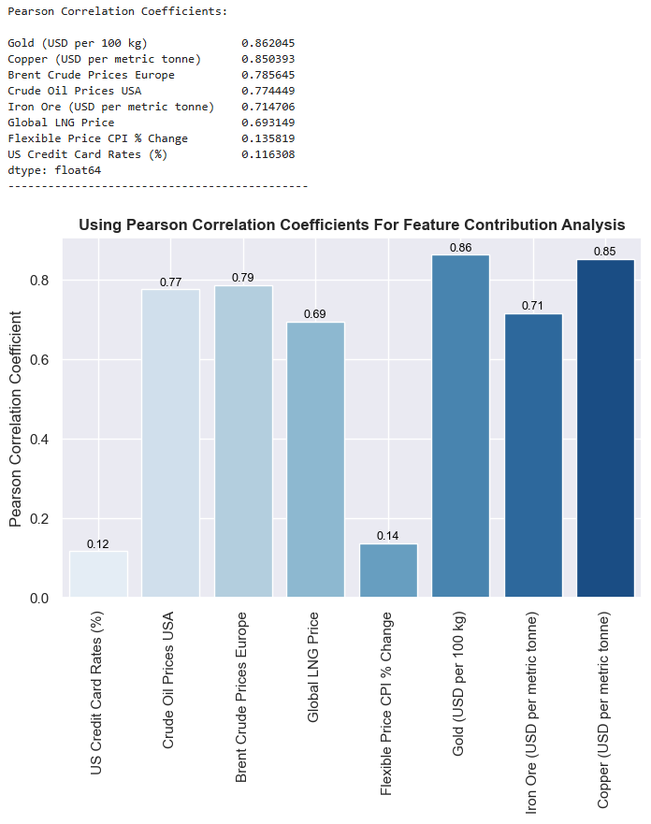
Figure 22. A bar plot of Pearson correlation coefficients visually representing the strength and direction of linear relationships between input features and the target variable, US manufacturers’ sales (USD $, millions).
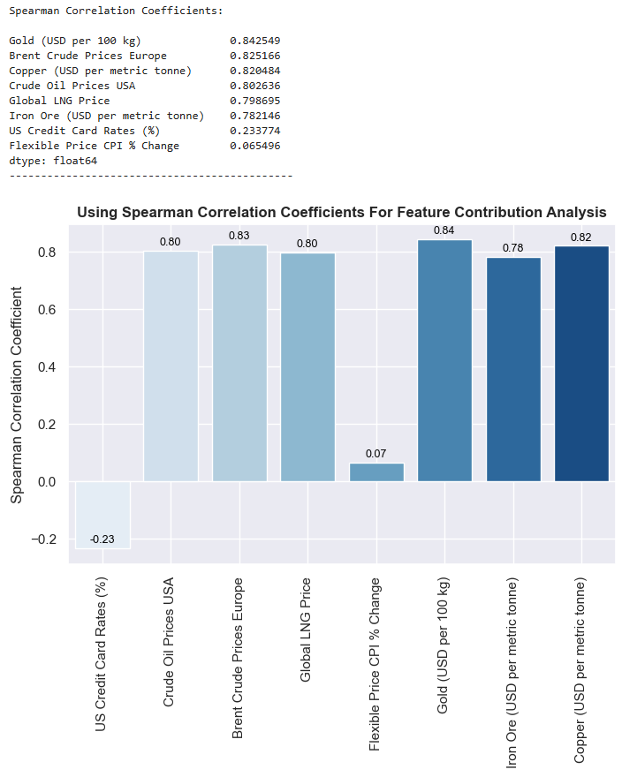
Figure 23. A bar plot of Spearman correlation coefficients visually representing the strength and direction of linear relationships between input features and the target variable, US manufacturers’ sales (USD $, millions).
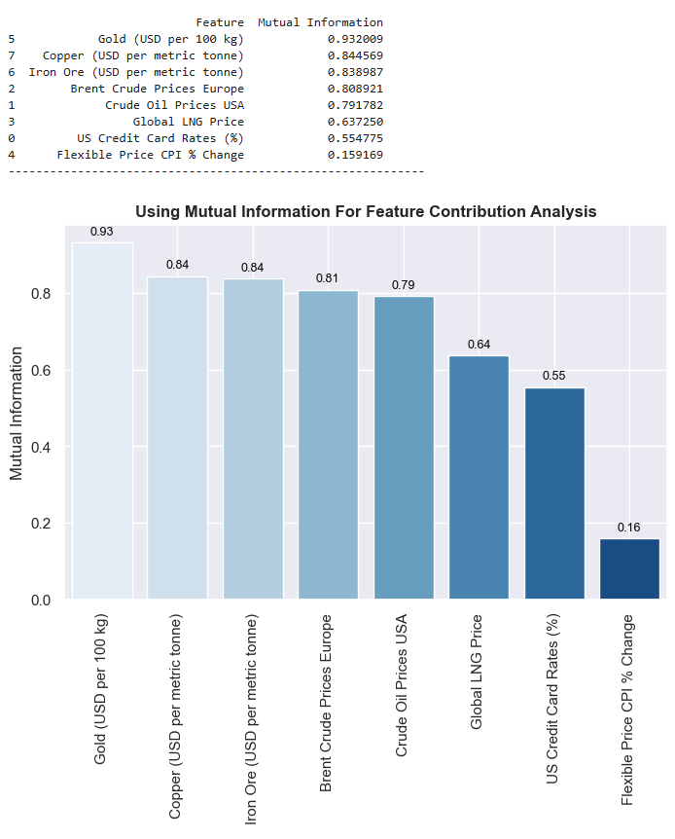
Figure 24. A bar plot using mutual information for feature contribution analysis shows how much each input feature contributes to predicting or understanding the target variable, US manufacturers’ sales (USD $, millions).
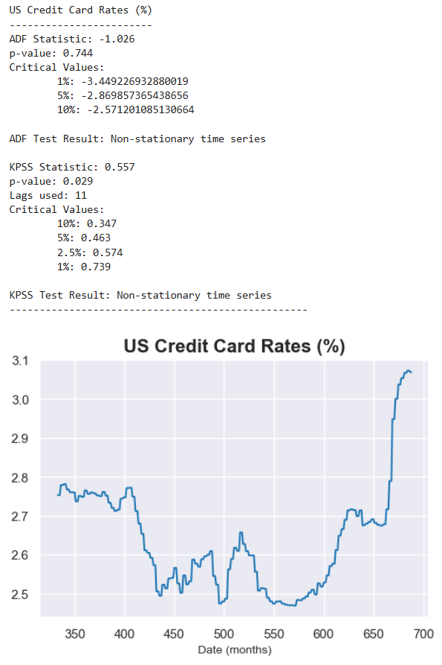
Figure 25. Results of stationarity tests relating to US credit card rates (%). Both tests, ADF and KPSS confirm that the time series data is non-stationary (unit root).
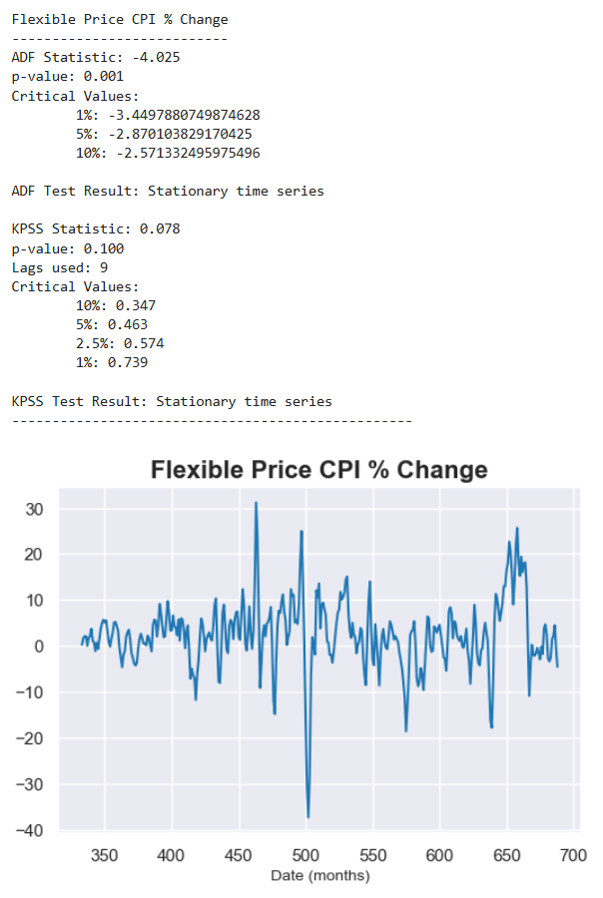
Figure 26. Results of stationarity tests relating to Flexible Price CPI (% change). Both tests, ADF and KPSS confirm that the time series data is stationary.
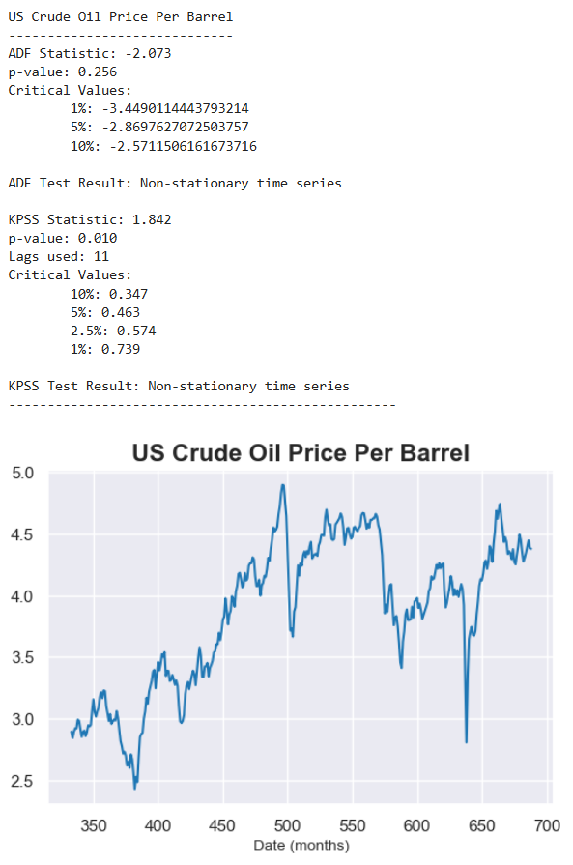
Figure 27. Results of stationarity tests relating to US crude oil prices (USD $ per barrel). Both tests, ADF and KPSS confirm that the time series data is non-stationary (unit root).
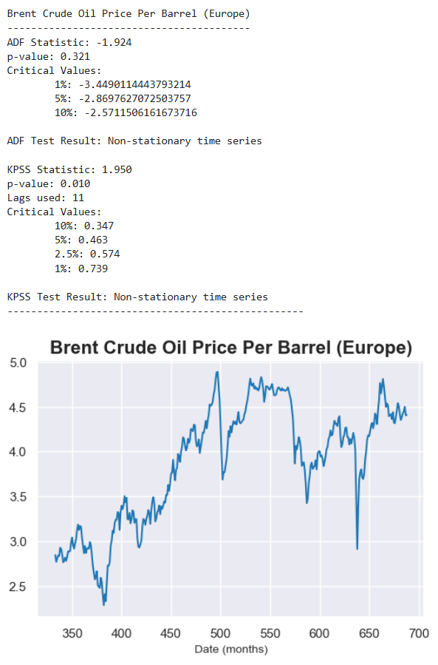
Figure 28. Results of stationarity tests relating to Brent crude oil prices (USD $ per barrel). Both tests, ADF and KPSS confirm that the time series data is non-stationary (unit root).
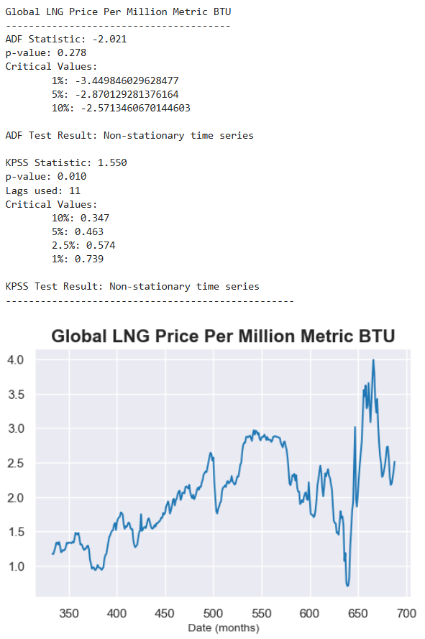
Figure 29. Results of stationarity tests relating to LNG prices (USD $ per million metric BTU). Both tests, ADF and KPSS confirm that the time series data is non-stationary (unit root).
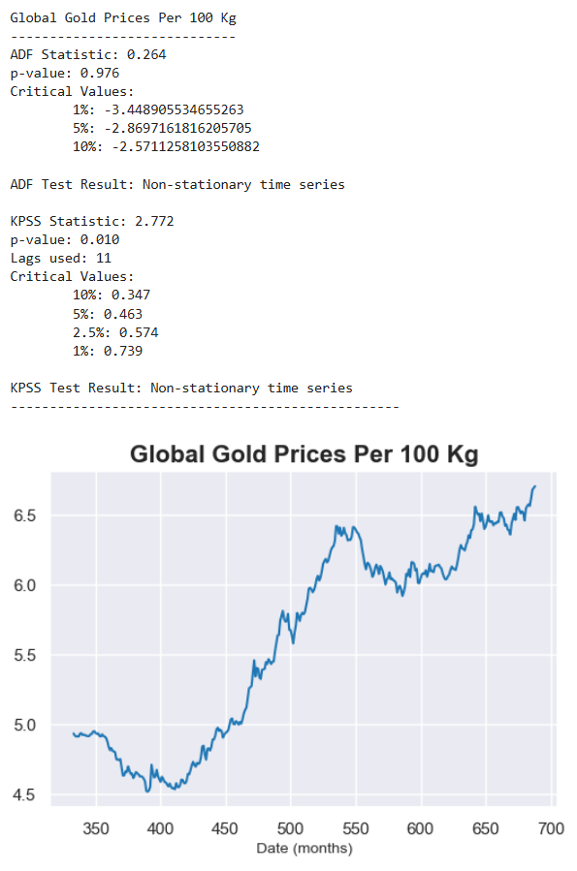
Figure 30. Results of stationarity tests relating to gold prices (USD $ per 100kg). Both tests, ADF and KPSS confirm that the time series data is non-stationary (unit root).
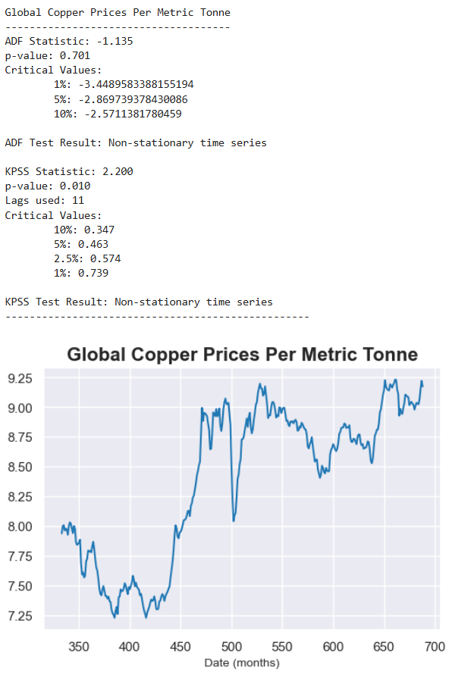
Figure 31. Results of stationarity tests relating to copper prices (USD $ per metric tonne). Both tests, ADF and KPSS confirm that the time series data is non-stationary (unit root).
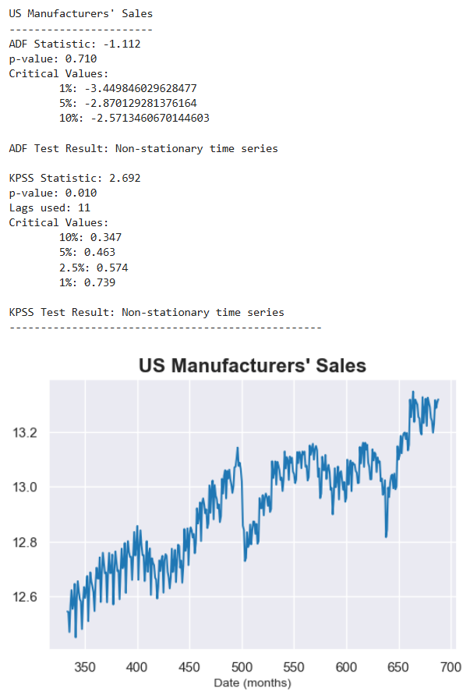
Figure 32. Results of stationarity tests relating to US manufacturers' sales (USD $, millions). Both tests, ADF and KPSS confirm that the time series data is non-stationary (unit root).
Figure 25 to Figure 32 show the results of stationarity tests and associated time series plots. With the exception of “Flexible Price CPI (% change)”, ADF and KPSS tests confirmed the non-stationary nature of the time series plots. In other words, the time series data exhibited changes in statistical properties such as the mean, variance, and covariance over time (Baidya and Lee, 2024). Accordingly, it was imperative to transform the data to attain stationarity before further exploratory analysis was conducted. [80]

In this study, the adverse impact of non-stationarity was mitigated using a technique called “detrending by differencing” (Perktold et al., 2023). To remove trends and render the time series data stationary, the previous observation was iteratively subtracted from the current observation. This process is encapsulated by the following mathematical expression:
Y_{t} − Y_{t−1}
After detrending the data, stationarity tests were conducted to ascertain if the unit roots have been removed. The results of these tests are shown in Figure 33 to Figure 41. It is self-evident that the time series data has been rendered trend stationary, notwithstanding conflicting test results for US credit card rates. [105]

Figure 42 displays the correlation matrices for the dataset, with the upper portion representing detrended time series data and the lower portion showing unadjusted data. The correlation coefficients for the input features in the detrended matrix are significantly lower compared to those in the unadjusted matrix. It is plausible that seasonality and other economic factors exert an oversized influence on US manufacturers’ sales. Hence, it was imperative to retain seasonal fluctuations when modelling the time series data, otherwise unreliable and skewed predictions may ensue (Cerqueira et al., 2020). [88]

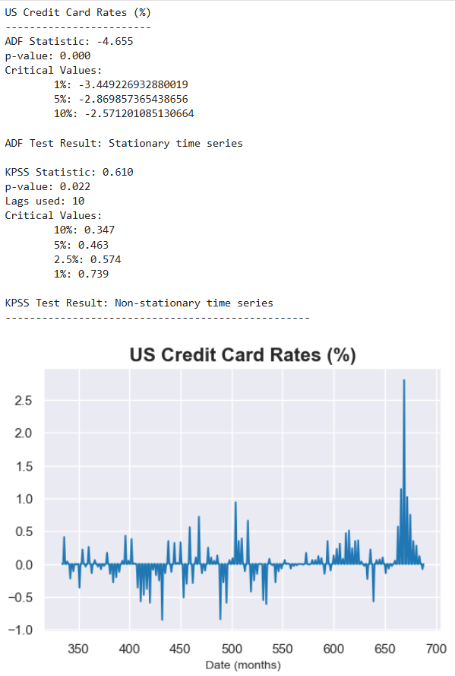
Figure 33. Results of stationarity tests relating to detrended US credit card rates (%). The ADF test confirms that the detrended time series is stationary whereas the KPSS test confirms non-stationarity.
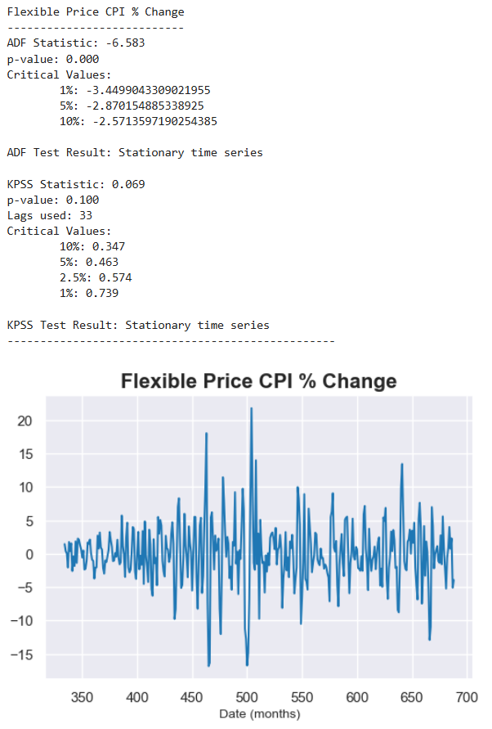
Figure 34. Results of stationarity tests relating to detrended Flexible Price CPI (% change). Both tests, ADF and KPSS confirm that the time series data is stationary.
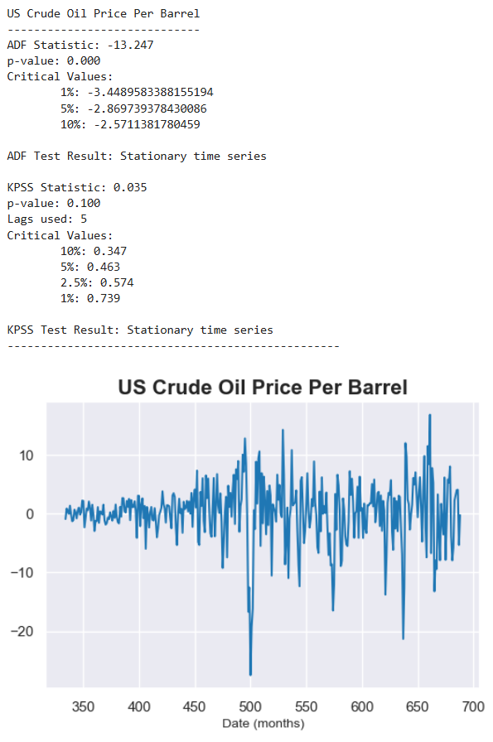
Figure 35. Results of stationarity tests relating to detrended US crude oil prices (USD $ per barrel). Both tests, ADF and KPSS confirm that the time series data is stationary.
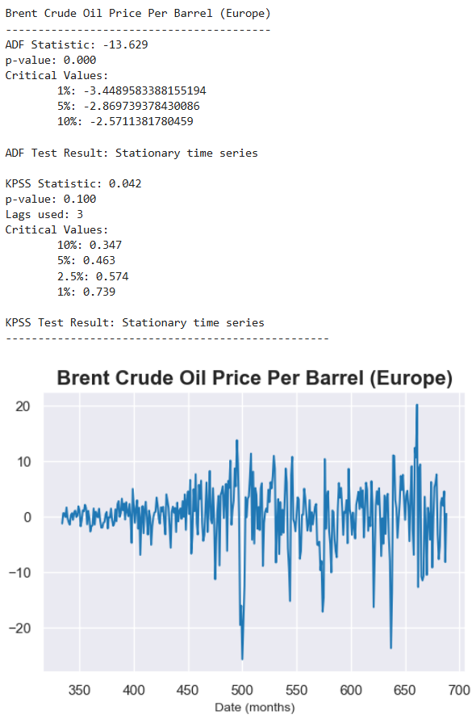
Figure 36. Results of stationarity tests relating to detrended Brent crude oil prices (USD $ per barrel). Both tests, ADF and KPSS confirm that the time series data is stationary.
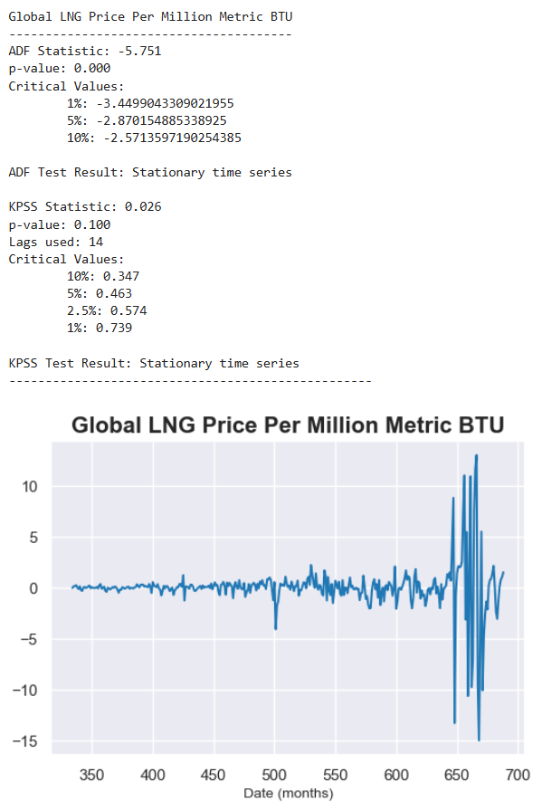
Figure 37. Results of stationarity tests relating to detrended LNG (USD $ prices per million metric BTU). Both tests, ADF and KPSS confirm that the time series data is stationary.
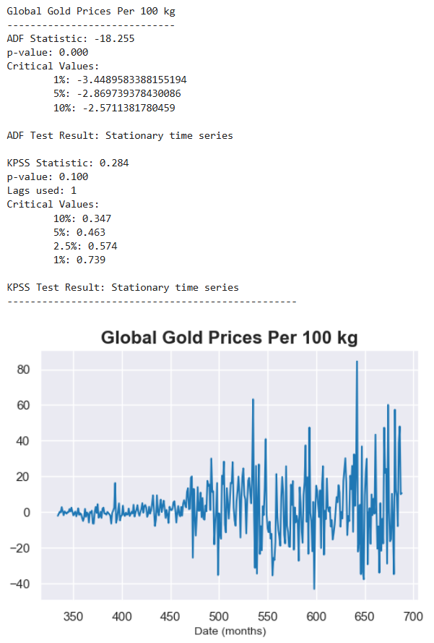
Figure 38. Results of stationarity tests relating to detrended gold prices (USD $ per 100kg). Both tests, ADF and KPSS confirm that the time series data is stationary.
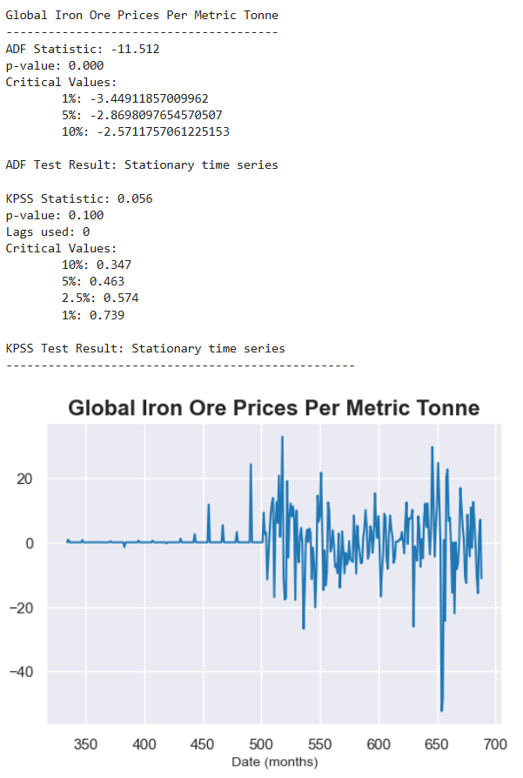
Figure 39. Results of stationarity tests relating to detrended iron ore prices (USD $ per metric tonne). Both tests, ADF and KPSS confirm that the time series data is stationary.
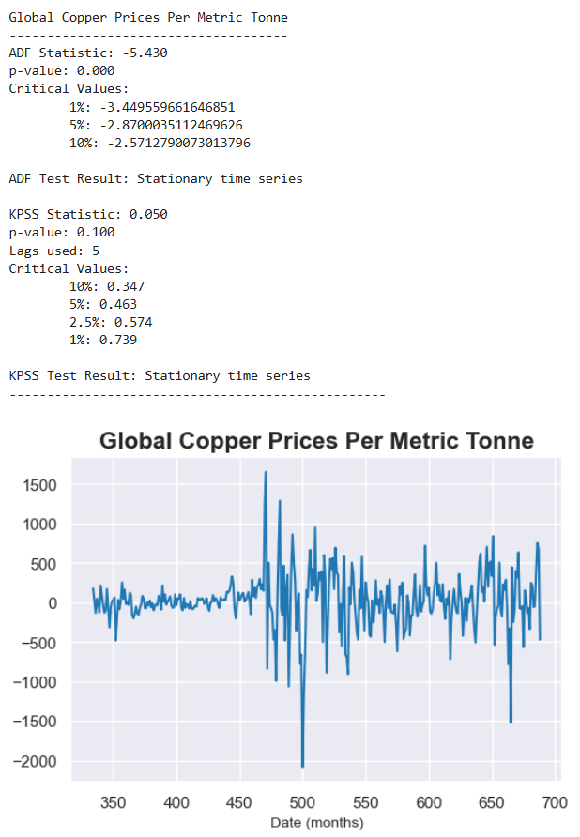
Figure 40. Results of stationarity tests relating to detrended copper prices (USD $ per metric tonne). Both tests, ADF and KPSS confirm that the time series data is stationary.
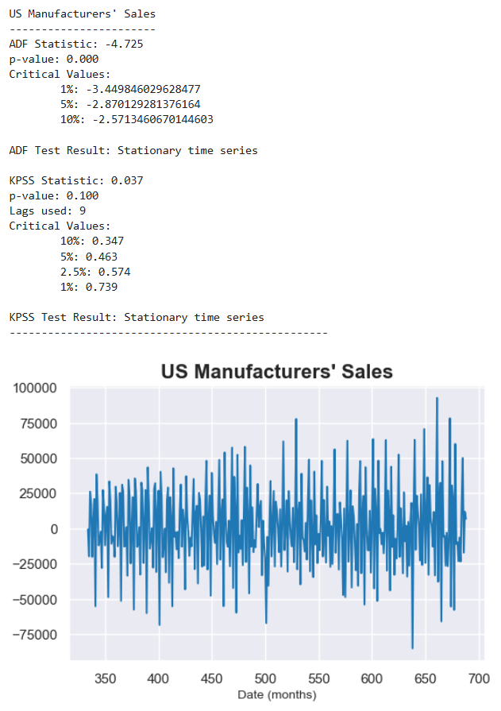
Figure 41. Results of stationarity tests relating to detrended US manufacturers' sales (USD $, millions). Both tests, ADF and KPSS confirm that the time series data is stationary.
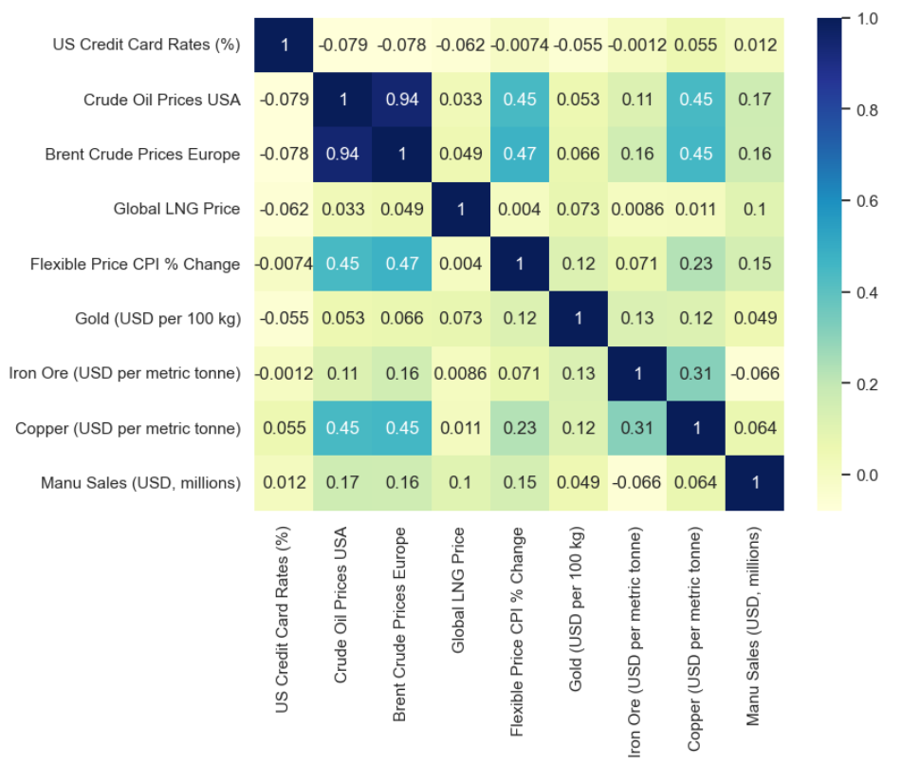

Figure 42. Correlation matrices for the detrended (upper) and unadjusted (lower) time series data.

Modelling

Non-stationary normalised time series data as presented in Figure 43 was used to train the following four conventional machine learning algorithms:

- Gradient Boosting Regressor (GBR)
- Random Forest Regressor (RFR)
- Support Vector Regressor (SVR)
- XG Boost Regressor (XGB)

A type of neural network architecture called SimpleRNN is also trained on the data. [51]
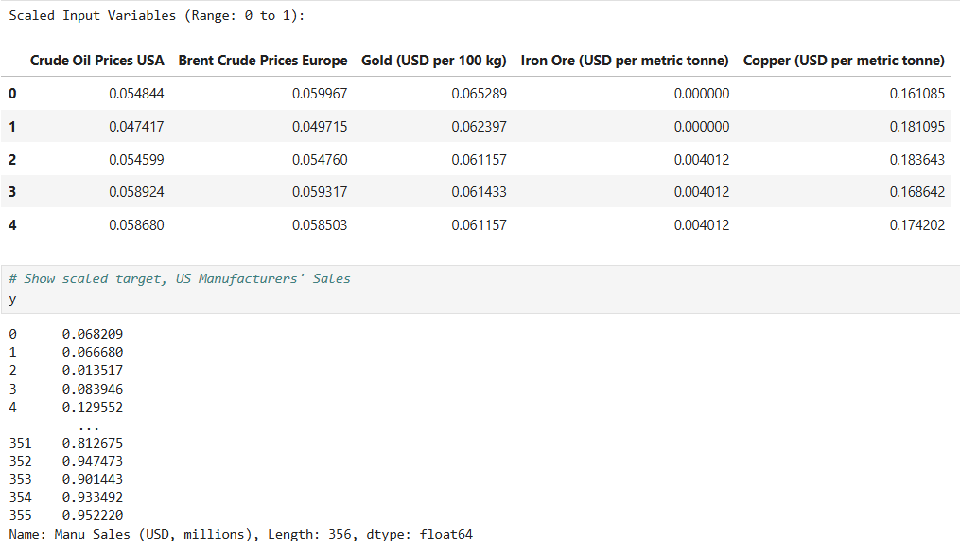
Figure 43. Normalised data relating to selected input features and target variable, US manufacturers' sales (USD $, millions).
Since the objective of this study was to develop a singular tuned model capable of forecasting future economic output in the United States, selected input features were adjusted to include both unlagged data and data lagged by 1 month relative to the target variable. This approach enabled the evaluation of whether incorporating a temporal lag enhanced or reduced predictive accuracy. On foot of this analysis, the most effective feature mix for anticipating future economic trends was determined. [77]

Moreover, the optimal test split (10%, 15%, 20%, 25%, or 30%) was ascertained, and hyperparameter tuning was conducted using GridSearchCV and the optimal test split. The tuned models were then used to predict the target variable, US manufacturers’ sales, ensuring optimised model performance and robust forecasting outcomes. [47]

Whilst the ARIMA algorithm is commonly used for analysing and forecasting time series data (Siami-Namini et al., 2018), modelling was not conducted with this algorithm. Indeed, time series forecasting was not the objective of this study. [36]

Evaluation

To evaluate model accuracy and performance, a wide range of different evaluation metrics were used:

- Mean Absolute Error (MAE)
- Mean Absolute Squared Error (MSE)
- Root Mean Squared Error (RMSE)
- Mean Absolute Percentage Error (MAPE)

Using these metrics as a guide, the optimal test split size and best-performing model were identified to ensure reliable predictions. Moreover, feature ablation and SHAP analyses were performed to identify the features most critical to the tuned model’s predictive output. In summary, these methodologies provided a comprehensive understanding of feature importance and enhanced the model's predictive accuracy for economic forecasting. [94]

Untuned Model evaluation

The untuned models were trained on unlagged normalised data across various test split sizes. The results of model evaluation are presented in Figure 44 to Figure 48. Suffice it to say that the optimal test split size for the best untuned model, XGB, is 20%. This test split size was subsequently used to re-appraise the performance of the tuned models, ensuring consistency in the model evaluation process. [67]
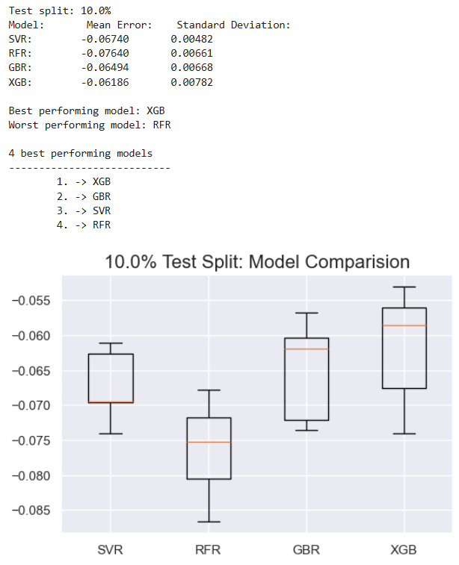
Figure 44. Boxplots illustrating model performance results for several untuned models trained and evaluated using a 10% test split size.
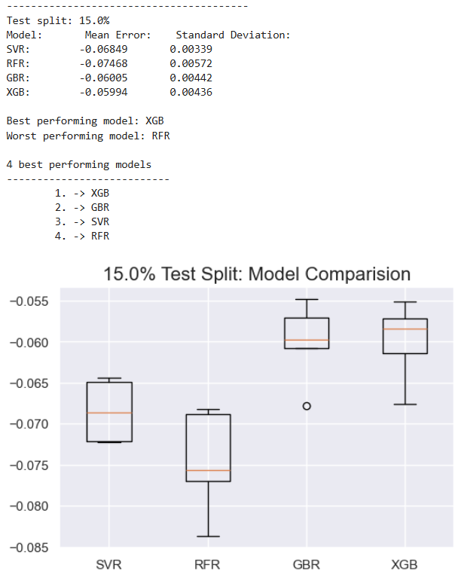
Figure 45. Boxplots illustrating model performance results for several untuned models trained and evaluated using a 15% test split size.
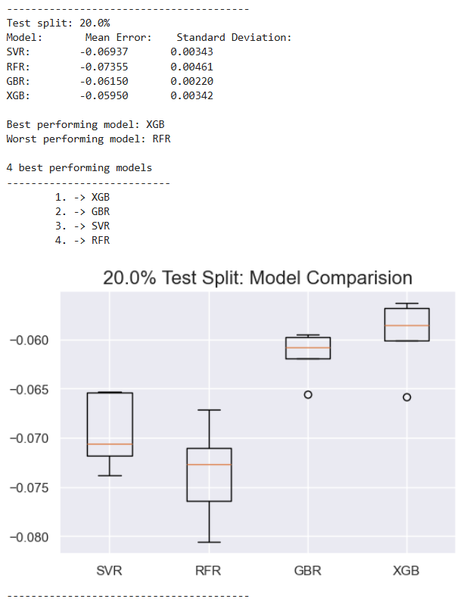
Figure 46. Boxplots illustrating model performance results for several untuned models trained and evaluated using a 20% test split size.
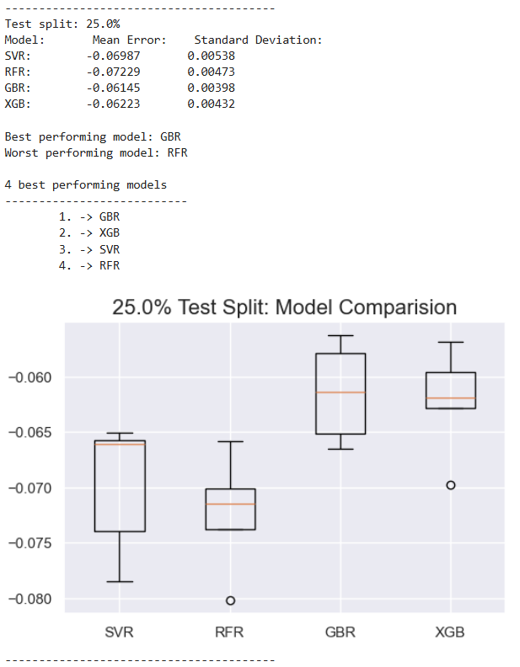
Figure 47. Boxplots illustrating model performance results for several untuned models trained and evaluated using a 25% test split size.
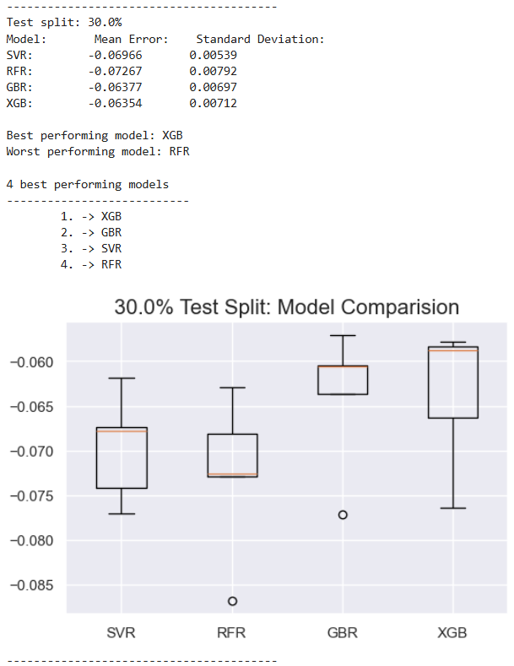
Figure 48. Boxplots illustrating model performance results for several untuned models trained and evaluated using a 30% test split size.
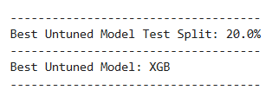

Tuned Model evaluation

The tuned models were trained on unlagged and lagged normalised data using the optimal 20% test split size. The input features were lagged by 1 month relative to the target variable, US manufacturers’ sales. Based on the findings presented in Figure 49, the best tuned model was XGB. [48]

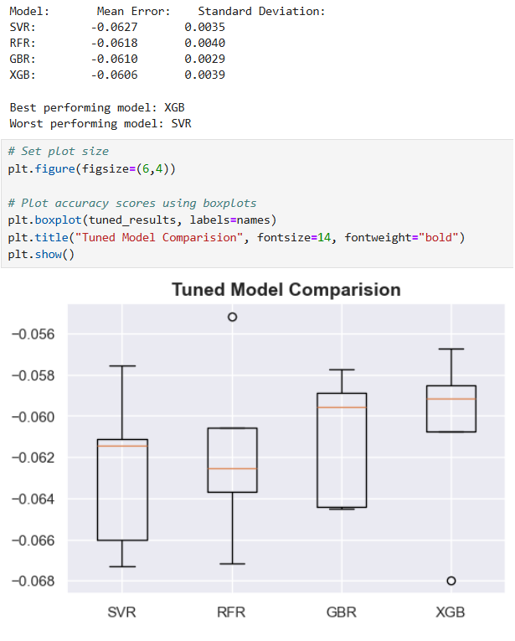
Figure 49. Boxplot illustrating model performance results for several tuned models trained and evaluated using a 20% test split size.
Figure 50 presents a comparison between actual US manufacturers' sales data and the corresponding predictions generated by the best tuned model, XGB. The analysis reveals that the Mean Absolute Percentage Error (MAPE) is 12.47% for the unlagged data (upper line plot), showing a relatively high degree of accuracy. However, for the input features lagged by 1 month (lower line plot), the MAPE increases to 23.1%. This signals a marked decline in model performance, with an observed deterioration of 10.63% when predicting the target variable using lagged data. [87]

In Figure 51, the results of residual analysis conducted on the best tuned model, XGB, using both unlagged (upper plot) and lagged (lower plot) features are presented. In both instances, the analysis shows no concrete evidence of the normalised data underfitting or overfitting the model. This indicates that the residuals are well-distributed, with no systematic patterns or biases (Bobbitt, 2023). This finding suggests that the model effectively captures the latent relationships in the data, thereby rendering the model robust and generalisable. [81]
In Figure 52, Shapley Additive Explanation (SHAP) values for both unlagged (upper plot) and lagged (lower plot) features are presented. These plots help to understand which features are the most impactful and how changes in their values affect the predictive accuracy of the model (Yadav, 2024). In the unlagged feature plot, gold and copper exert the most influence on the tuned model’s decision-making process. Specifically, a wide range of SHAP values (from -0.1 to 0.2 approximately) for gold suggests it plays an instrumental role, with high values of this feature positively contributing to the model’s predictive output. To a slightly lesser extent, SHAP values (from -0.1 to 0.15 approximately) for copper also exert a significant impact on the tuned model’s output. The same findings are also applicable to the lagged feature set. [132]
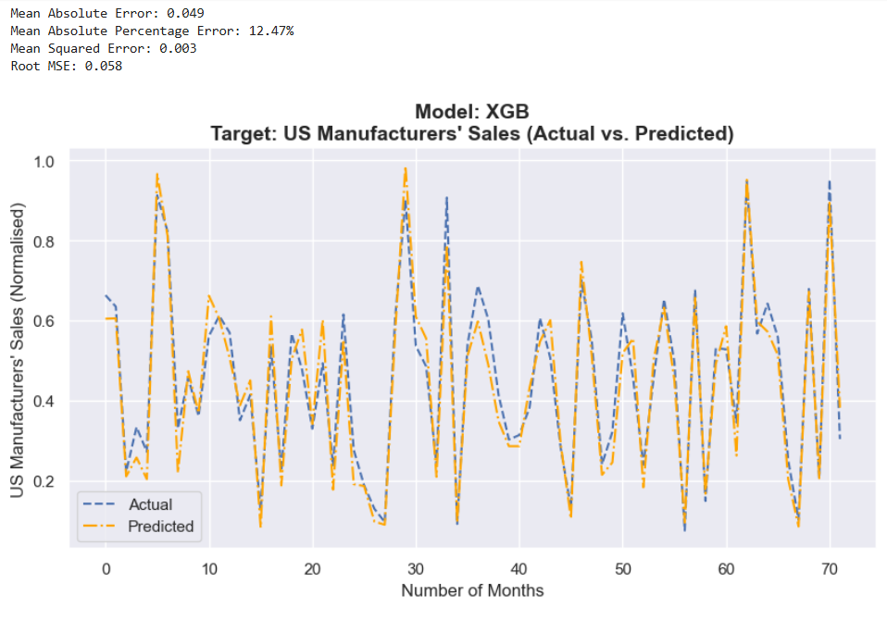
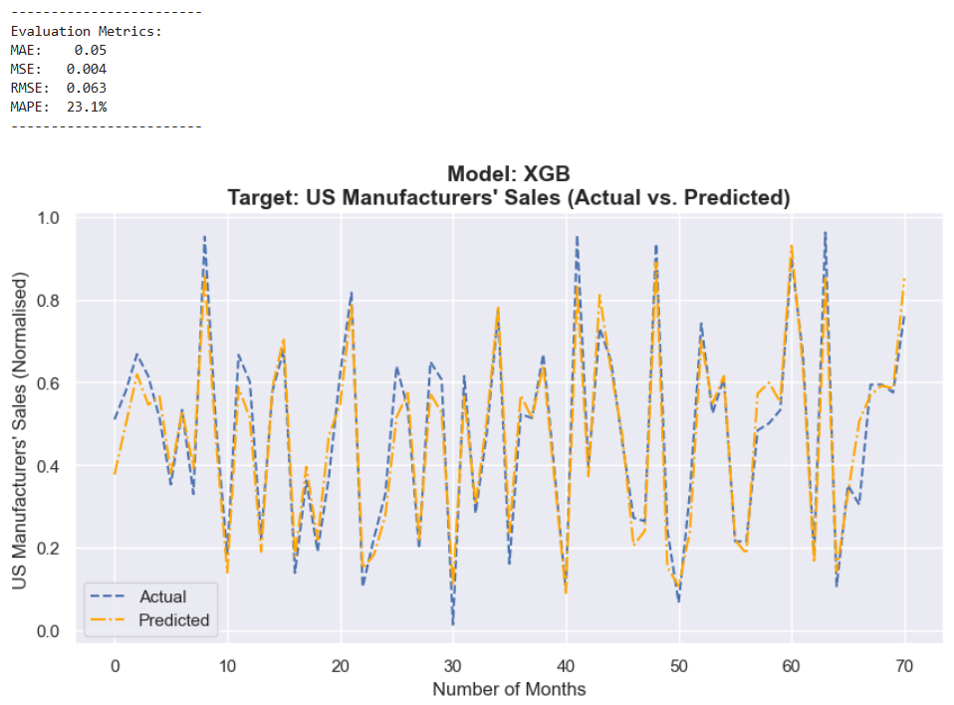
Figure 50. Comparison of actual US manufacturers' sales data with predictions from the best tuned model, XGB. The comparative analysis highlights a MAPE of 12.47% for unlagged data (upper plot) and 23.1% for data lagged by 1 month (lower plot).

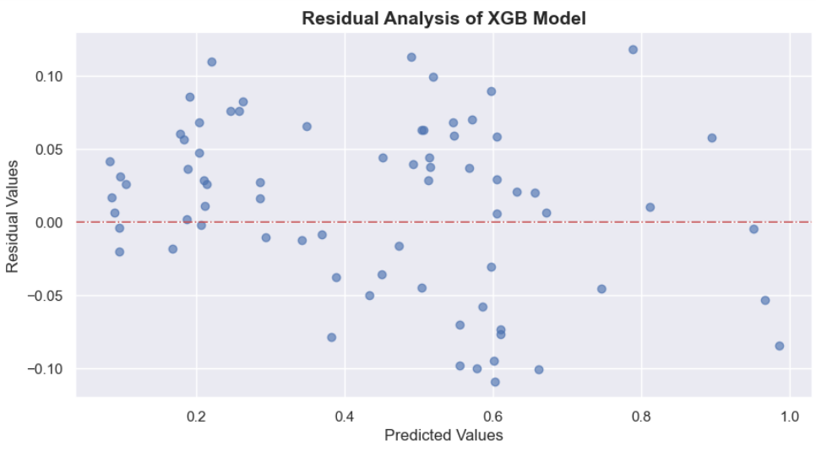
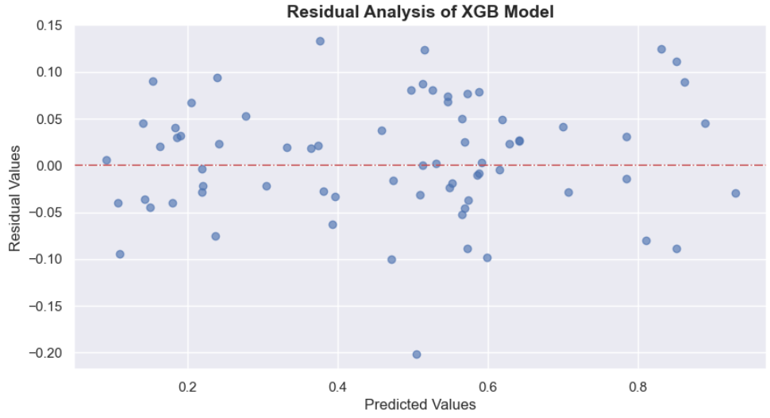

Figure 51. Residual analysis of the best tuned model, XGB, using unlagged (upper plot) and lagged (lower plot) features. The results show no evidence of model underfitting or overfitting.

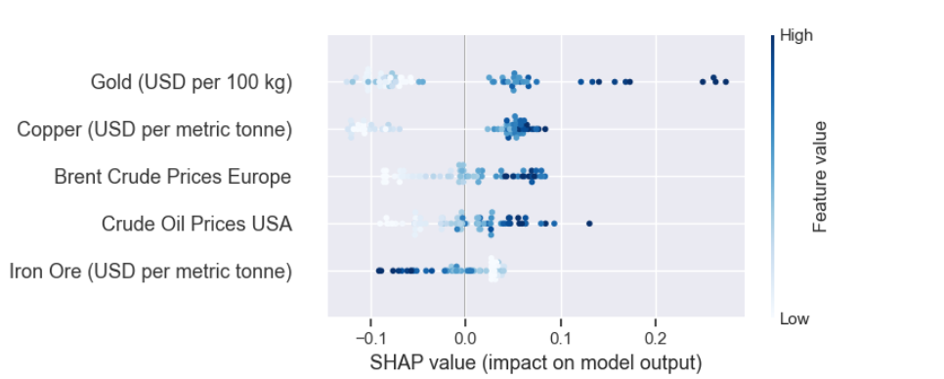
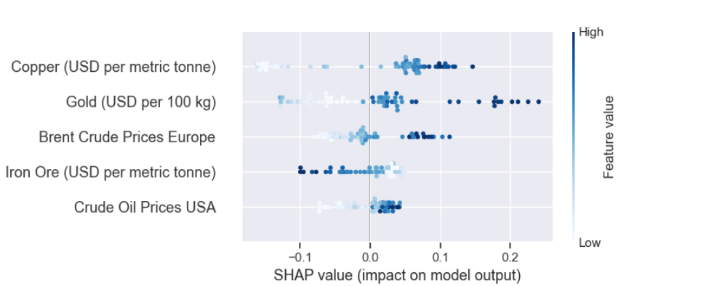

Figure 52. SHAP values for unlagged (upper plot) and lagged (lower plot) input features, illustrating each feature's contribution to tuned model predictions.
Figure 53 demonstrates the application of feature ablation analysis to identify the significance of individual features on the tuned model’s performance. By systematically removing one feature at a time and observing how the model’s predictive accuracy changes, it is feasible to determine which features are the most important when the model makes predictions (Merrick, 2019). In essence, feature ablation is imperative for optimising feature selection, reducing modelling complexity, and improving model interpretability (Theng and Bhoyar, 2024). [76]

In a similar vein to residual and SHAP analyses, feature ablation was conducted using unlagged and lagged normalised data. The upper bar plot in Figure 53 pertains to unlagged features. The two features that exert the most influence on the tuned model’s predictive output are gold and iron ore. Since gold prices exhibit the highest MSE score of 0.0060, this feature has the most significant impact on model performance. Iron ore has an MSE score of 0.0047, signalling its substantial contribution to the model’s predictive accuracy. The same findings are applicable to the feature set lagged by 1 month relative to the target variable: the MSE score for gold is 0.0069, and the MSE score for iron ore is 0.0046. [120]

The relatively high MSE scores for gold and iron ore suggest that these features exert the most significant impact on model accuracy. This is true for both unlagged and lagged feature sets. Indeed, these two features may serve as useful signals when attempting to forecast future economic output in the United States. For instance, if both gold and iron ore prices display a simultaneous upward trajectory in the current month, it is possible that economic activity in the following month might also exhibit a corresponding upward trend. [87]
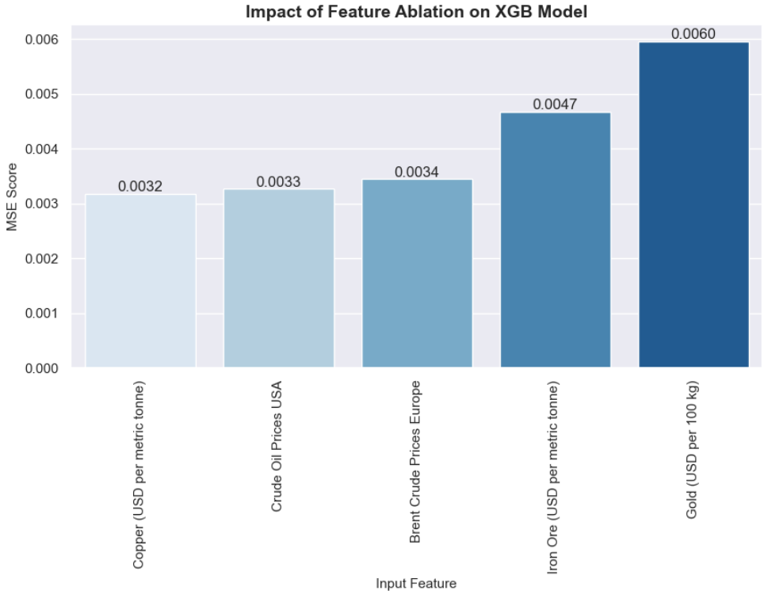
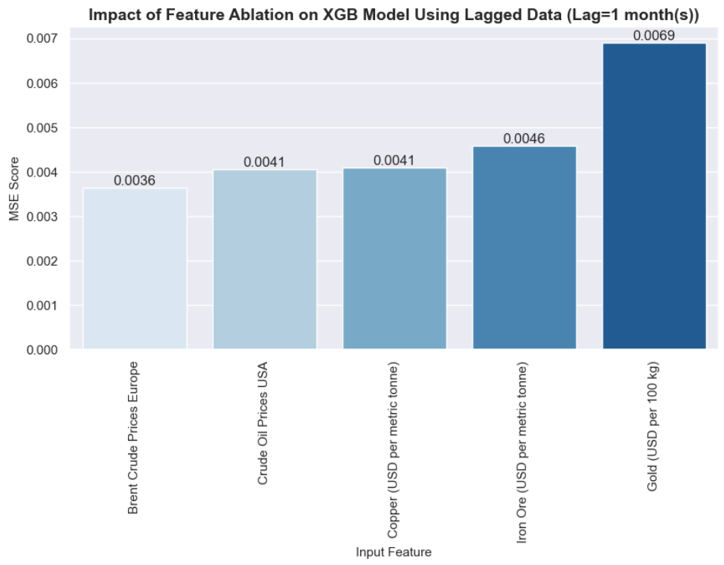
Figure 53. Bar plots illustrating the results of feature ablation analysis for both unlagged (upper plot) and lagged (lower plot) normalised data.
Furthermore, it is plausible that savvy investors privy to “inside information” regarding potential future economic growth, strategically invest in specific commodities – such as gold and iron ore – thereby driving up their market prices. This dynamic interplay between investor behaviour and shifts in commodity prices underlines the potential predictive value of these signals. [52]

Nevertheless, economic output is influenced by a myriad of factors that were not explored in this study. In consequence, there is no guarantee that changes in these potential signals will consistently translate into corresponding shifts in economic output. Further research is necessary to validate these preliminary findings and draw more definitive conclusions while taking into consideration other influencing factors. [59]

RNN Model evaluation

For the sake of comparison, a Recurrent Neural Network (RNN) was trained on unlagged normalised data using the optimal 20% test split. Since RNNs are typically optimised to capture temporal dynamics that traditional models might overlook, a basic RNN architecture called SimpleRNN was used to reveal novel insights about the data (Petnehazi, 2019). In this regard, evaluation of deep learning models can be compared with more conventional machine learning algorithms such as XGB to determine which modelling method yields the best predictive outcomes. [83]

Figure 54 presents the evaluation metrics for the trained SimpleRNN model using unlagged data. Contrary to expectations, the neural network did not perform better compared to XGB. In actuality, model performance was significantly worse with a MAPE score of 80.61%, whereas the corresponding evaluation metric for XGB was 12.47%. [49]

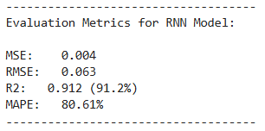
Figure 54. Evaluation metrics relating to trained SimpleRNN model after exposure to test data.

While the high R2 score of 0.912 suggests that the neural network effectively captured the relationships in the data, the high MAPE score signals that the trained model did not generalise well when exposed to test data. Indeed, it is possible that the model overfitted the training data, capturing patterns and trends that were not sufficiently generalisable, hence the wide discrepancy between actual and predicted values when the model was tested on unseen data. This glaring discrepancy is visualised in Figure 55. [82]

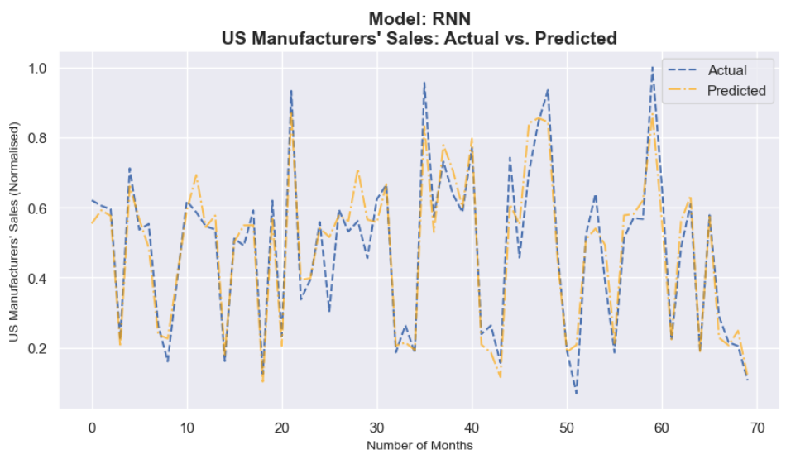
Figure 55. Comparison of actual US manufacturers' sales data with predictions generated by the trained SimpleRNN model.

To facilitate diagnosis of the model’s sub-optimal performance, residual analysis was conducted. In Figure 56, a residual analysis plot confirms that there are no discernible trends or patterns in the residuals, thereby indicating that the model’s predictions are unbiased with no manifest evidence of underfitting or overfitting. However, these results conflict with the high MAPE score. Possible reasons for this incongruence might be: (1) the model’s inadvertent failure to capture critical features or relationships that are essential to accurate predictions using unseen data, (2) training data does not contain sufficient observations to accurately represent the input features, (3) heavily skewed test data that unfavourably distort the MAPE score, (4) training duration is too long, and (5) the presence of outliers or “noise” in the test set, amongst other reasons (Vignesh, 2020). [131]

In light of the disappointing predictive capabilities of SimpleRNN vis-à-vis the target variable in the unlagged data, further model training and testing with data that incorporated a 1-month temporal lag was abandoned. It is anticipated that the lagged data would yield a significantly worse MAPE score, thereby negating any worthwhile predictive insights. This assumption is further underlined by the minimal variation in MSE scores across the input features when feature ablation is carried out. On visual analysis of Figure 56, it is patently clear that model performance was largely unaffected by the removal of any specific feature. [97]

Since the deep learning model exhibited an unsurprisingly high MAPE score coupled with minimal impact from feature ablation, it is apparent that SimpleRNN is not compatible with a low-dimensional feature space such as the data frame used in this study. The selected RNN architecture is clearly not suitable for predicting the target variable due to its inability to adequately decipher potential temporal dependencies, noise, and/or data complexity. Moreover, there may be latent overfitting or underfitting that is not openly acknowledged by residual analysis, thereby frustrating the predictive efficacy of the model (Mucci, 2025). [93]

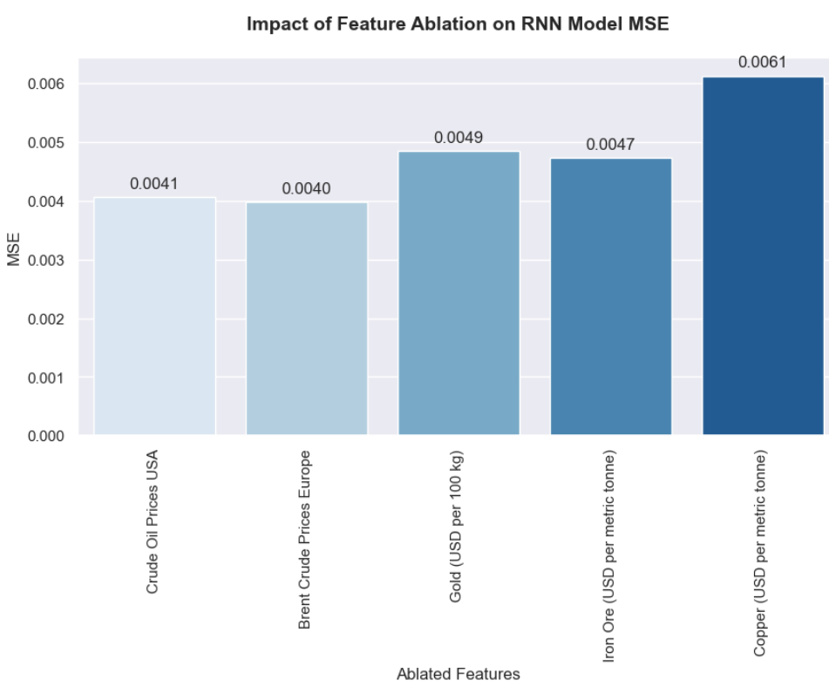
Figure 56. Bar plots illustrating the results of feature ablation analysis for SimpleRNN model.

Challenges

No significant and insurmountable challenges were experienced during this study. [10]

Conclusions

Exploratory data analysis of time series data extracted from the FRED repository revealed strong correlations between commodity prices for crude oil, gold, iron ore, and copper with the target variable, US manufacturers’ sales. When the data was detrended and unit roots were removed, the resultant data showed relatively weaker correlations between the independent and target variables respectively. This suggests that the relationships observed in the non-stationary data are mainly driven by latent trends and seasonal fluctuations in commodity prices as opposed to intrinsic causal linkages. Hence, subsequent modelling was conducted using non-stationary data. [93]

Conventional machine learning models performed significantly better relative to basic neural networks such as SimpleRNN. Specifically, the best tuned model was Extreme Gradient Boosting (XGB), although this model experienced a marginal disimprovement in performance when trained and evaluated on data exhibiting a temporal lag of 1 month. Feature ablation analysis using both unlagged and lagged data confirmed that commodity prices pertaining to gold and iron ore exerted the most impact on model performance. [73]

Suffice it to say these features may be leveraged as potential signals when forecasting changes in US manufacturers’ sales. Since economic activity is influenced by a myriad of factors not explored in this study, further research is necessary before definitive conclusions can be drawn about the optimal signal mix for economic forecasting. [52]

Recommendations

To develop a more accurate and comprehensive economic forecasting model, it is imperative to use a high dimensional dataspace that incorporates a broader range of commodity prices drawn from different sectors such as agriculture, energy, metals, and rare earths. External economic factors such as inflation, interest rates, labour data, GDP growth rates, and currency exchange rates should be taken into consideration when constructing the dataspace. Moreover, a wider range of modelling techniques (e.g., multivariate time series models, hybrid models, and advanced neural networks such as LSTMs and GRUs) should be employed to find the best model that consistently gives accurate forecasts. [101]

References

Abdullah, S. N., and Zeng, X. (2010). Machine learning approach for crude oil price prediction with Artificial Neural Networks-Quantitative (ANN-Q) model. In Proceedings of the International Joint Conference on Neural Networks. Proc Int Jt Conf Neural Networks IEEE.
https://doi.org/10.1109/IJCNN.2010.5596602

Atmakuru, A., Di Fatta, G., Nicosia, G., Badii, A. (2024). Improved Filter-Based Feature Selection Using Correlation and Clustering Techniques. In: Nicosia, G., Ojha, V., La Malfa, E., La Malfa, G., Pardalos, P.M., Umeton, R. (eds) Machine Learning, Optimization, and Data Science. LOD 2023. Lecture Notes in Computer Science, vol 14505. Springer, Cham.
https://doi.org/10.1007/978-3-031-53969-5_28

Baidya, R., Lee, S.W. (2024). Addressing the non-stationarity and complexity of time series data for long-term forecasts. Appl. Sci. 14(11), 4436.
https://doi.org/10.3390/app14114436

Baumeister, Christiane and Lutz Kilian. (2017) Lower oil prices and the U.S. economy: Is this time different? Brookings Papers on Economic Activity, 47, 287–357.

Baumeister, Christiane, Lutz Kilian, and Xiaoqing Zhou. (2018). Are product spreads useful for forecasting oil prices? An empirical evaluation of the Verleger Hypothesis. Macroeconomic Dynamics, 22, 562–80.

Bawdekar, A.A., Prusty, B.R., Bingo, K. (2022). Sensitivity analysis of stationarity tests' outcome to time series facets and test parameters.
https://doi.org/10.1155/2022/2402989

Binns, R. (2018). Fairness in Machine Learning: Lessons from Political Philosophy. In Proceedings of the 2018 Conference on Fairness, Accountability, and Transparency, 23-24 February 2018, New York, NY, United States.
https://proceedings.mlr.press/v81/binns18a/binns18a.pdf

Bobbitt, Z. (2023). What is Considered a Good vs. Bad Residual Plot? Statology.
https://www.statology.org/good-vs-bad-residual-plot/

Cabello-Solorzano, K., Ortigosa de Araujo, I., Peña, M., Correia, L., J. Tallón-Ballesteros, A. (2023). The Impact of Data Normalization on the Accuracy of Machine Learning Algorithms: A Comparative Analysis. In: García Bringas, P., et al. 18th International Conference on Soft Computing Models in Industrial and Environmental Applications (SOCO 2023). SOCO 2023. Lecture Notes in Networks and Systems, vol 750. Springer, Cham.
https://doi.org/10.1007/978-3-031-42536-3_33

Cerqueira, V., Torgo, L., Mozetič, I. (2020). Evaluating time series forecasting models: an empirical study on performance estimation methods. Machine Learning. 109:1997–2028.
https://doi.org/10.1007/s10994-020-05910-7

Chandra Blessie, E., Karthikeyan, E. (2012). Sigmis: A Feature Selection Algorithm Using Correlation Based Method. Journal of Algorithms & Computational Technology, 6(3): 385-394.

Chatfield, C. (2000). Time-Series Forecasting. Chapman and Hall/CRC, New York, United States. https://doi.org/10.1201/9781420036206

Doppelt, R. (2023). Should Macroeconomists Use Seasonally Adjusted Time Series? Structural Identification and Bayesian Estimation in Seasonal Vector Autoregressions. Department of Economics, Indiana University Bloomington, United States. pp. 5-6.
https://economics.indiana.edu/documents/should-macroeconomists.pdf

Fernando, J. (2024). Precious Metals: Definition, How To Invest, and Example.
https://www.investopedia.com/terms/p/preciousmetal.asp

Kim, K., Lim, S., Lee, C., Lee, W.J., Jeon, H., Jung, J., and Jung, D. (2022). Forecasting Liquefied Natural Gas Bunker Prices Using Artificial Neural Network for Procurement Management. J. Mar. Sci. Eng. 2022, 10(12), 1814.
https://doi.org/10.3390/jmse10121814

Kumar, B. (2025). Data Preprocessing in Machine Learning.
https://pythonguides.com/data-preprocessing-in-machine-learning/

Liberto, D. (2024). Economic Forecasting: Definition, Use of Indicators, and Example. Investopedia.
https://www.investopedia.com/terms/e/economic-forecasting.asp

Luna, Zipporah (2021). Feature Selection in Machine Learning: Correlation Matrix, Univariate Testing, and RFECV. Medium.
https://medium.com/geekculture/feature-selection-in-machine-learning-correlation-matrix-univariate-testing-rfecv-1186168fac12

Mamedli, M. (2021). Machine Learning Real-Time CIP Forecasting. In: IFC-Bank of Italy Workshop On “Machine Learning in Central Banking". p. 3.
https://www.bis.org/ifc/publ/ifcb57_18.pdf

Maverick, J.B. (2023). Do changes in interest rates affect consumer spending? Investopedia.
https://www.investopedia.com/ask/answers/071715/how-do-changes-interest-rates-affect-spending-habits-economy.asp

Merrick, L. (2019). Randomized Ablation Feature Importance. Cornell University, https://doi.org/10.48550/arXiv.1910.00174

Mucci, T. (2025). Overfitting vs. underfitting: Finding the balance. IBM.
https://www.ibm.com/think/topics/overfitting-vs-underfitting

Murry, C. (2022). How the iron ore market works. Investopedia.
https://www.investopedia.com/articles/investing/030215/how-iron-ore-market-works-supply-market-share.asp#toc-what-is-iron-ore

Petnehazi, G. (2019). Recurrent Neural Networks for Time Series Forecasting. Cornell University, United States. https://doi.org/10.48550/arXiv.1901.00069

Scott, G. (2021). Copper: Meaning, Price Determinants, and Future. Investopedia. https://www.investopedia.com/terms/c/copper.asp

Qin, Q., Huang, Z., Zhou, Z., Chen, C., and Liu, R. (2023). Crude Oil Price Forecasting With Machine Learning And Google Search Data: An Accuracy Comparison Of Single-Model Versus Multiple-Model. Engineering Applications of Artificial Intelligence. Vol. 123(a), 106266.
https://doi.org/10.1016/j.engappai.2023.106266

Song, F., Guo, Z., and Mei, D. (2010). Feature Selection Using Principal Component Analysis. 2010 International Conference on System Science, Engineering Design and Manufacturing Informatization, Yichang, China, 2010, pp. 27-30. https://doi.org/10.1109/ICSEM.2010.14

Theng, D., Bhoyar, K.K. (2024) Feature selection techniques for machine learning: a survey of more than two decades of research. Knowl Inf Syst, 66, 1575–1637. https://doi.org/10.1007/s10115-023-02010-5

US Federal Government, 2020. The Economic Benefits of Oil and Gas. US Department of Energy.
https://www.energy.gov/articles/economic-impact-oil-and-gas#:~:text=The%20oil%20and%20gas%20industry,and%20ensures%20our%20energy%20security.

Vignesh, S. (2020). The Perfect Fit for a DNN. Medium.
https://medium.com/analytics-vidhya/the-perfect-fit-for-a-dnn-596954c9ea39#

Yadav, A. (2024). SHAP Values Explained. Medium.
https://medium.com/biased-algorithms/shap-values-explained-08764ab16466

Yang, S.F., Choi, S.W. and Lee, E.B. (2023). A Prediction Model for Spot LNG Prices Based on Machine Learning Algorithms to Reduce Fluctuation Risks in Purchasing Prices. Energies 2023, 16(11), 4271.
https://doi.org/10.3390/en16114271 [658]

GitHub link:
https://github.com/Darren-SBA23255-CCT-L8/Strategic_Thinking_HCI_S2

